**Colorado Technical University**

**Course:** MATH366 – Probability and Statistics

**Unit 2 Part 04 Readings: Box Plots**

**Five number summary:** minimum, first quartile, median, third quartile, and maximum

**Boxplots** are a standardized way of displaying how the data is distributed using the

five number summary

Also called a box and whisker diagram

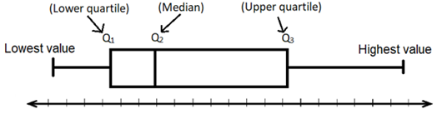

Boxplots can be used to compare different datasets:

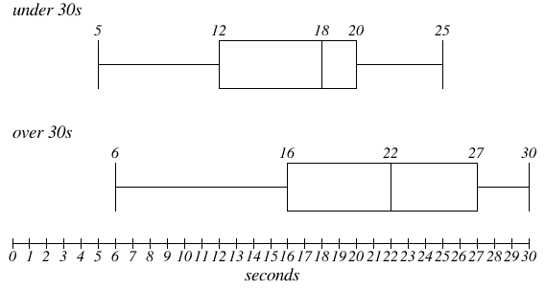

It is customary to conclude that if two

boxplots’ boxes overlap, they

are not different

If they do not overlap, even if the

whiskers do, they *are* different

Because the min and max may be outliers, a variation on the boxplot includes “fences”

to show where most of the data occurs

**Lower fence: Q1 - 1.5 * IQR**

**Upper fence: Q3 + 1.5 * IQR**

Data outside of the fences are potentially "outliers"

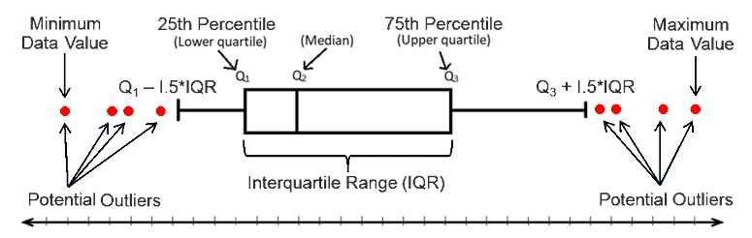

There are a lot of variations in making boxplots:



https://www.researchgate.net/figure/Six-different-boxplot-variations-All-the-boxplots-are-representing-an-Ex-Gaussian_fig1_50946370