**Colorado Technical University**

**Course:** MATH207 – Integral Calculus

#### Unit 10 Part 20 Readings: Vector Calculus

**Vector Calculus**

A **vector-valued function** is a function of the form: $\vec{\text{r}}$ **= ƒ(t) $\hat{\text{i}}$ + g(t) $\hat{\text{j}}$ + h(t) $\hat{\text{k}}$** where the

component functions ƒ, g, and h are real-valued functions of the parameter t

They are also written: $\vec{\text{r}}$ **(t) = ⟨f(t),g(t),h(t)⟩**

**Limits**

A vector-valued function $\vec{\text{r}}$ approaches the limit $\vec{\text{L}}$ as t approaches a, written:

Lim(t→a) (t) = $\vec{\text{L}}$, provided Lim(t→a) ∥(t)- $\vec{\text{L}}$ ∥=0

**Addition Rule**:

Lim(t→a) [ƒ(t) $\hat{\text{i}}$ + g(t) $\hat{\text{j}}$ + h(t) $\hat{\text{k}}$] = [Lim(t→a) ƒ(t)] $\hat{\text{i}}$ + [Lim(t→a) g(t)] $\hat{\text{j}}$ + [Lim(t→a) h(t)] $\hat{\text{k}}$

(provided the limits Lim(t→a)ƒ(t), Lim(t→a)g(t) and Lim(t→a)h(t) exist)

**Continuity**:

The vector-valued function $\vec{\text{r}}$ = ƒ(t) $\hat{\text{i}}$ + g(t) $\hat{\text{j}}$ + h(t) $\hat{\text{k}}$ is continuous at point t=a if:

$\vec{\text{r}}$ (a) exists

Lim(t→a)(t) exists

Lim(t→a)(t) = $\vec{\text{r}}$ (a)

**Derivatives**

We can extend the properties of the derivative to vector-valued functions

For product rule, remember there are two types of “vector multiplication”: the dot

product and the cross product

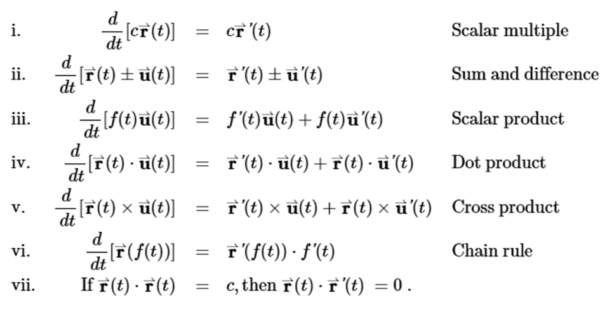 Table of derivatives for vector-valued function multiplication:

**Principal Unit Tangent Vector**

A tangent vector at t=t0 is any vector such that, when the tail of the vector is

placed at point (t0) on the graph, vector $\vec{\text{r}}$ is tangent to curve C

Vector '(t0) is a tangent vector at point t=t0

Defined to be:

$\vec{\text{T}}$ (t) = $\vec{\text{r}}$’(t) / ∥ $\vec{\text{r}}$’(t)∥

provided ∥ $\vec{\text{r}}$ (t)∥≠0

**Integration**

**Addition Rule:**

The indefinite integral of a vector-valued function $\vec{\text{r}}$ = ƒ(t) $\hat{\text{i}}$ + g(t) $\hat{\text{j}}$ + h(t) $\hat{\text{k}}$ is:

∫[ƒ(t) $\hat{\text{i}}$ + g(t) $\hat{\text{j}}$ + h(t) $\hat{\text{k}}$] dt = ∫[ƒ(t) $\hat{\text{i}}$]dt + ∫[g(t) $\hat{\text{j}}$]dt + ∫[h(t) $\hat{\text{k}}$]dt

When you do the integration for an indefinite integral, each of the components will have

its own “+c”

Therefore, the integration constants become a constant vector!

**Vector Applications**

Vectors and vector spaces have a wide variety of applications in engineering and the

physical sciences

In physics, a vector space consists of arrows in a fixed plane starting at one fixed point

This is used to describe forces or velocities

Conventions for the arrows:

the direction of a vector is a counterclockwise angle of rotation about the vector's

"tail" from due east

the magnitude of a vector is depicted by the length of the arrow

**Kinematics "How Things Move"**

In Newton's laws of motion, the **net force** experienced by an object is determined by

computing the vector sum of all the individual forces acting upon that object

The net force is the result (**resultant**) of adding up all the force vectors

The **resultant** is the vector sum of two or more vectors

The net force will have two components: magnitude and direction

Free-body diagrams illustrate net force with only a limited number of forces working on

the object

The Pythagorean theorem is a useful method for determining the magnitude of the

resultant of adding two (and only two) vectors that make a right angle (and only



c2 = a2 +b2

a right angle) to each other:

Trigonometry can be used to calculate the exact direction

For two vectors, the angle will be: tan-1

arctan $\left(\frac{second vector length}{first vector length}\right)$ (Wolfram)

degrees $\left(atan\left(\frac{second vector length}{first vector length}\right)\right)$ (Excel)

You may have to adjust the angle value for the quadrant you are in

**http://www.1728.org/vectors.htm** is a vector addition calculator

The order in which three vectors are added has no effect upon either the magnitude or the

direction of the resultant

The resultant will still have the same magnitude and direction

**Distance** is a scalar quantity that refers to "how much ground an object has covered" during its

motion

**Displacement** is a vector quantity that refers to "how far out of place an object is“

It is the object's overall change in position

If displacement vectors A, B, and C are added, the result will be displacement vector R

When vectors are directed at **angles** to customary coordinate axes, transform the vector into

two parts with each part being directed along the coordinate axes

This is the “ai + bj” form of writing vectors

The process of determining the magnitude of a vector is known as **vector resolution**

A calculator for vector components:

**http://www.physicsclassroom.com/Class/vectors/u3l1e.cfm**

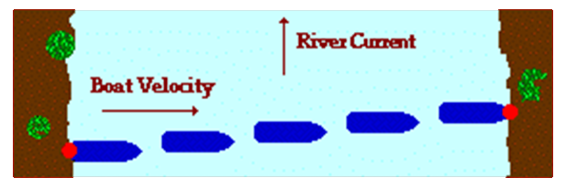**The river - boat problem**

The boat's motor is what carries the boat

across the river the Distance A

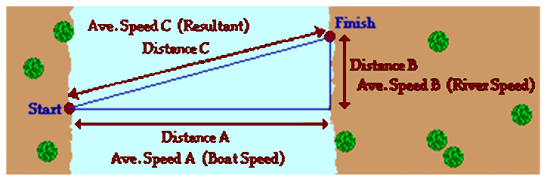

So any calculation involving the Distance A must involve the speed value labeled as Speed A

(the boat speed relative to the water)

Similarly, it is the current of the river that carries the boat downstream for the Distance B

So any calculation involving the Distance B must involve the speed value labeled as Speed B

(the river speed)

Together, these two parts (or components) add up to give the resulting motion of the boat

The across-the-river component of displacement adds to the downstream displacement to

equal the resulting displacement

Likewise, the boat velocity (across the river) adds to the river velocity (down the river) to equal

the resulting velocity

