**Colorado Technical University**

**Course:** MATH207 – Integral Calculus

#### Unit 8 Part 16 Readings: Transforms

**Integral Transforms**

An integral transform is a particular kind of

mathematical operator

An integral transform is any transformed function Tƒ:

Tƒ(u) = $\int_{t_{1}}^{t_{2}}{K\left(t,u\right)f\left(t\right)dt}$

The input of this transform is a function ƒ, and the

output is another function Tƒ

**Howcum?**

There are many classes of problems that are hard to

solve in their original form

An integral transform "maps" an equation from its

original "domain" into another domain

Manipulating and solving the equation in the target

domain can be much easier

The solution is then mapped back to the

original domain with the inverse of the integral transform

**Fourier Series**

Using the Fourier series, just about any

practical function of time (the

voltage across the terminals of

an electronic device for example)

can be represented as a sum of

sines and cosines, each suitably

scaled (multiplied by a constant

factor), shifted (advanced or

retarded in time) and "squeezed"

or "stretched" (increasing or

decreasing the frequency)

**Fourier Transforms**

The Fourier transform

decomposes a function of time (a signal) into the frequencies that make it up, similarly to how a musical chord can be expressed as the amplitude (or loudness) of its constituent notes

For many functions of practical interest one can define an

operation that reverses this: the inverse Fourier transformation, also called Fourier synthesis, of a frequency domain representation combines the contributions of all the different frequencies to recover the original function of time

Any linear time-invariant system, such as an electronic filter

applied to a signal, can be expressed relatively simply

as an operation on frequencies

Significant simplification is often achieved by transforming time functions to the

frequency domain, performing the desired operations, and transforming the result

****back to time

Joseph Fourier introduced the transform in his study of heat transfer

**The Laplace Transform**

Laplace Transforms are used to reduce a differential equation to

an algebra problem

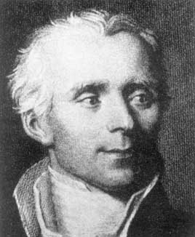The Laplace Transform is especially useful when the initial

values are zero

The Laplace Transform is widely used in electronic engineering

applications, especially where the driving force is

discontinuous

The Laplace Transform is often used in circuit analysis, and

simple conversions to the s-Domain of circuit elements

can be made

Circuit elements can be transformed into impedances, very

similar to phasor impedances

The techniques of Laplace Transform are not only used in circuit analysis, but also in

Proportional-Integral-Derivative (PID) controllers

DC motor speed control systems

DC motor position control systems

Second order systems of differential equations (underdamped, overdamped and

critically damped)

The Laplace transform of a function (t) for t > 0 is defined by the following integral defined over

0 to ∞:

L{ƒ(t)} = ∫0∞ e – pt ƒ(t) dt

The resulting expression is a function of p, which we write as F(p). In words we say:

The Laplace Transform of ƒ(t) equals function F of p

and write: L {ƒ(t)} = F(p)

Similarly, the Laplace transform of a function g(t) would be written: L {g(t)} = G(p)

#### An inverse Laplace transform brings back the original function

If G(p) = L {g(t)}, then the **inverse transform** of G(p) is defined as:

L 1G(p) = g(t) (Use invlap on the TI89)

**Notation:**

A Laplace transform is symbolized by: *L* or $L$

It is common to indicate time domain quantities as lower case such as ƒ or ƒ(t)

Common practice is also to use upper case for the Laplace domain (or the *complex*

*frequency domain*), such as F

Sometimes upper case is used for DC quantities and lower case for AC quantities

We will use ƒ(*s*) for the Laplace domain to make it very clear

British practice is to use *p* for *s* (this is used on the TI89 App)

#### Table of Laplace Transforms

| **Time Function ƒ(t)**    ƒ(t) = *L*-1{F(s)} | **Laplace Transform of ƒ(t)** F(s) = *L*{ƒ(t)} |
| --- | --- |
| 1 | $\frac{1}{s}$ s > 0 |
| t (unit-ramp function) | $\frac{1}{s^{2}}$ s > 0 |
| t n (n, a positive integer) | $\frac{n!}{s^{n+1}}$ s > 0 |
| eat | s > a |
| sin ωt | $\frac{ω}{s^{2}+ω^{2}}$ s > 0 |
| cos ωt | $\frac{s}{s^{2}+ω^{2}}$ s > 0 |
| tng(t), for n = 1, 2, ... | $${(-1)}^{n} \frac{d^{n}G(s)}{{ds}^{n}}$$ |
| t sin ωt | $\frac{2ωs}{{{(s}^{2}+ω^{2})}^{2}}$ s > |ω| |
| t cos ωt | $\frac{s^{2}-ω^{2}}{{{(s}^{2}+ω^{2})}^{2}}$ s > |ω| |
| g(at) | $\frac{1}{a}G\left(\frac{s}{a}\right)$ Scale property |
| eatg(t) | G(s − a)   Shift property |
| eattn, for n = 1, 2, ... | $\frac{n!}{{(s-a)}^{n+1}}$ s > a |
| te-t | s > –1 |
| 1 − e-t/T | s > $\frac{-1}{T}$ |
| eatsin ωt | $\frac{ω}{{(s-a)}^{2}+ω^{2}}$ s > a |
| eatcos ωt | $\frac{s-a}{{(s-a)}^{2}+ω^{2}}$ s > a |
| u(t) | $\frac{1}{s}$ s > 0 |
| u(t − a) | $\frac{e^{-as}}{s}$ s > 0 |
| u(t − a)g(t − a) | $e^{-as}G(s)$ Time-displacement theorem |
| g'(t) | sG(s) − g(0) |
| g''(t) | s2G(s) − sg(0) − g' (0) |
| g(n)(t) | sn G(s) − sn-1 g(0) − sn-2 g'(0) − ... − g(n-1)(0) |
| $$\int_{0}^{t}{g\left(t\right)dt}$$ | $$\frac{G(s)}{s}$$ |
| $$\int{g\left(t\right)dt}$$ | $${\frac{G(s)}{s}+ \frac{1}{s}\left\{\int{g\left(t\right)dt}\right\}}_{t=0}$$ |

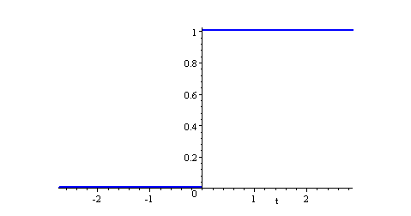**The Heaviside (Unit Step) Function**

Definition: The unit step function, *u*(*t*), is defined as

0 *t* < 0

1 *t* > 0

{

*u*(*t* ) *=*

That is, *u* is a function of time *t*,

and *u* has value zero when time is

negative (before we flip the switch);

and value one when time is positive

(from when we flip the switch).

The sketch of the waveform is:

# Rectangular Pulse

A common situation in a circuit is for a voltage to be applied at a particular time

(say *t* = *a*) and removed later, at *t* = *b* (say).

0 *t* < *a*

1 *a* <*t* < *b*

0 *t* > *b*

{

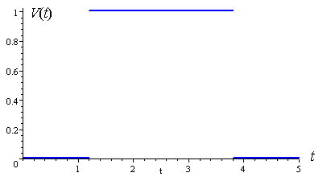

*V*(*t* ) *=*

Such a situation is written using unit

step functions as:

*V*(*t*) = *u*(*t* − *a*) − *u*(*t* − *b*)

This voltage has strength 1,

duration (*b* − *a*).

Example: The graph of:

*V*(*t*) = *u*(*t* − 1.2) − *u*(*t* − 3.8) is:

Here, the duration is 3.8 − 1.2 = 2.6.

Using the TI89 to solve Laplace transforms

Use the downloaded Laplace function

Home CATALOG F4 select LAPL,

enter the DiffEq, comma,

the independent variable

(on the bottom of the derivative ratio),

close parenthesis, enter

Tah Dah!

The @ numbers are the constants "C" or "K"

The "s" on this Laplace Transforms sheet

is a "p" on the TI89

For inverse Laplace, use invlap on the TI89

