Colorado Technical University
Course: MATH207 – Integral Calculus

Unit 7 Part 13 Readings: Convergence
Convergence
Limit of a series – does it converge on the right value or does it diverge?
Squeeze theorem for sequences
Let {a_{n}} {b_{n}} and {c_{n}} be sequences with a_{n} ≤ b_{n} ≤ c_{n} for all intergers n greater
than some index N
lim
n →∞
lim
k →∞
lim
k →∞
If a_{n} = c_{n} = L then b_{n} = L
lim
k →∞

Divergence test: If a series converges, then the = 0
lim
k →∞
If ≠ 0, then the series diverges
Harmonic series: 1 + 1/2 + 1/3 + 1/4 + 1/5 + …
Does it converge?
Divergence test
Cannot be used to prove convergence
Σ a_{k}
∞
_{k=1}
Form of series:
lim
k →∞
Condition for divergence: (a_{k}) ≠ 0
Integral test: Suppose f is a continuous, positive, decreasing function for x ≥ 1 and let
a_{k} = ƒ(k) for k = 1, 2, 3, … then
Σ ar^{k}
∞
_{k=1}

and $\int_{1}^{∞}{f\left(x\right)dx}$

either both converge or both diverge

In the case of convergence, the value of the integral is not, in general, equal to

the value of the series.
The p-series: the Integral test is used to analyze the convergence of an entire family of
∞
_{k=1}
Σ
1
p^{k}
infinite series known as the p-series:

Ratio test: If in a positive series the ratio of any general term to the preceding term
approaches a limit L as n →∞ then the series is convergent if L < 1 and
divergent if L> 1 or if the ratio →∞ as n →∞
If L = 1, the test fails
∞
_{k=1}
Σ
1
k^{p}
Root Test:
Let be an infinite series with nonnegative terms
lim
k →∞

and let p = a_{k}^{1/k}
- If 0≤p<1 the series converges
2. If p>1, (including p = ∞), the series diverges
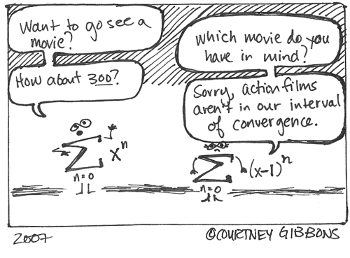
3. If p = 1, the test is inconclusive

Comparison Tests
Used when all else fails

Special Series and Convergence Tests

Series or Test | Form of Series | Cond for Conv | Cond for Div | Comments
Geometric series | Σ ar^{k}  ∞  _{k=1} | |r|<1 | |r|≥1 | If |r|<1 then  sum = a/(1-r)
Divergence test | Σ a_{k}  ∞  _{k=1} | Does not apply | a_{k} ≠ 0  lim  k →∞ | Cannot be used to prove conv
Integral test | Σ a_{k}  ∞  _{k=1}  Where a_{k}=ƒ(k) and ƒ is cont, pos and decr | $\int_{1}^{∞}{f\left(x\right)dx}< ∞$ | $\int_{1}^{∞}{f\left(x\right)dx}$ does not exist | The value of the integral is not the value of the series
p-series | ∞  _{k=1}  Σ  1  p^{k} | p>1 | p≤1 | Useful for comparison tests
Ratio test | Σ a_{k}  ∞  _{k=1}  where a_{k}>0 | lim  k →∞  <1  a_{k+1}  a_{k} | lim  k →∞  >1  a_{k+1}  a_{k} | Inconclusive if  lim  k →∞  =1  a_{k+1}  a_{k}
Root test | Σ a_{k}  ∞  _{k=1}  where a_{k}≥0 | $\sqrt[k]{a_{k}}$ < 1  lim  k →∞ | $\sqrt[k]{a_{k}}$ > 1  lim  k →∞ | Inconclusive if  lim  k →∞  $\sqrt[k]{a_{k}}$ = 1
Comparison test | Σ a_{k}  ∞  _{k=1}  Σ b_{k}  ∞  _{k=1}  where a_{k}>0 | 0<a_{k}≤b_{k} and  converges | 0<b_{k}≤a_{k} and  Σ b_{k}  ∞  _{k=1}  diverges | Σ a_{k}  ∞  _{k=1}  is given;  you supply  Σ b_{k}  ∞  _{k=1}
Limit comparison test | where  Σ a_{k}  ∞  _{k=1}  a_{k}>0, b_{k}>0 | 0≤ $\frac{a_{k}}{b_{k}}$ <∞  Σ b_{k}  ∞  _{k=1}  lim  k →∞  and  converges | $\frac{a_{k}}{b_{k}}$ > 0  lim  k →∞  Σ b_{k}  ∞  _{k=1}  and  diverges | Σ a_{k}  ∞  _{k=1}  is given;  you supply  Σ b_{k}  ∞  _{k=1}
Alternating series test | Σ (–1)^{k}a_{k}  ∞  _{k=1}  where  a_{k}>0, 0<a_{k+1}≤a_{k} | a_{k} = 0  lim  k →∞ | a_{k} ≠ 0  lim  k →∞ | Remainder R_{n} satisfies  R_{n} < a_{n+1}

