Colorado Technical University
Course: MATH207 – Integral Calculus

Unit 5 Part 9 Readings: Partial Derivatives

Partial Derivatives
If z = ƒ (x,y) then partial derivatives will be used
This function must be such that for every pair of x- and y- values
there exists a unique z

Common notations: ∂z/∂x ∂z/∂y ƒ_{x} ƒ_{x} (x,y)

When evaluating a function at ∂z/∂x
y is treated as a constant (held steady)
only x is allowed to vary
(8y = 8yx0 ) with a derivative of 0 * 8 * x * y = 0
Consider z as a function with only one variable, x, and find
the derivative as normal with y considered a constant
For ∂z/∂y hold x steady and vary y
Full derivative - combine and multiple by appropriate partial
Once the partial derivative is found, evaluate each partial by
replacing the variable with its value from (x, y, z) and solve
Each partial derivative will return the slope of a line tangent to the
surface at that three-space point parallel to the respective
axis

Higher-Order Partial Derivatives
Remember, we had higher-order derivatives with functions of one variable?
They looked like:
y" = $\frac{d^{2}y}{dx^{2}}$
You could keep going: y’’’ y’’’’ …
We will also have higher-order derivatives of functions of more than one variable
In single variable calculus we saw that the second derivative is often useful: in
appropriate circumstances it measures acceleration; it can be used to identify
maximum and minimum points; it tells us something about how sharply curved a graph is
Not surprisingly, second derivatives are also useful in the multi-variable case, but again
not surprisingly, things are a bit more complicated
It’s easy to see where some complication is going to come from: with two variables
there are four possible second derivatives
To take a “derivative,” we must take a partial derivative with respect to x or y, and there
are four ways to do it: x then x, x then y, y then x, y then y

For a function of two variables ƒ(x,y), there will be a total of four possible second-order
derivatives:
ƒ_{xx} = $\frac{∂^{2}ƒ}{∂x^{2}}$
ƒ_{yy} = $\frac{∂^{2}ƒ}{∂y^{2}}$
ƒ_{xy} = $\frac{∂^{2}ƒ}{∂y∂x}$
ƒ_{yx} = $\frac{∂^{2}ƒ}{∂x∂y}$
The last two second-order partial derivatives are often called mixed partial derivatives
because we are taking derivatives with respect to more than one variable
Note that the-order that we take the derivatives in is given by the notation:
ƒ_{xy} means first differentiate with respect to x then with respect to y
$\frac{∂^{2}ƒ}{∂y∂x}$ means first differentiate with respect to x then with respect to y
Example: Find all the second-order derivatives for e^{xy}
Solution
First find the first-order partial derivatives:
ƒ_{x} = $\frac{∂(e^{xy})}{∂x}$ = ye^{xy}
ƒ_{y} = $\frac{∂(e^{xy})}{∂y}$ = xe^{xy}
Now, let’s get the second-order derivatives:
ƒ_{xx} = $\frac{∂^{2}(e^{xy})}{∂x^{2}}$ = $\frac{∂(ye^{xy})}{∂x}$ = y²e^{xy}
ƒ_{yy} = $\frac{∂^{2}(e^{xy})}{∂y^{2}}$ = $\frac{∂(xe^{xy})}{∂y}$ = x²e^{xy}
ƒ_{xy} = $\frac{∂^{2}(e^{xy})}{∂y∂x}$ = $\frac{∂(ye^{xy})}{∂y}$ = xye^{xy} + e^{xy} or e^{xy}(xy +1)
ƒ_{yx} = $\frac{∂^{2}(e^{xy})}{∂x∂y}$ = $\frac{∂(xe^{xy})}{∂x}$ = xye^{xy} + e^{xy} or e^{xy}(xy +1)
Notice that ƒ_{xy} = ƒ_{yx}
This will be true for almost all of the functions you will run into in your life (discontinuous
functions are the exception to the rule)
If partials have the same value, they are not “distinct”
Clairaut’s Theorem: If the mixed partial derivatives are continuous, they are equal.
There are, of course, even higher-order partial derivatives as well
How many third-order partial derivatives would there be for a two-variable function?
ƒ_{xxx} ƒ_{yxx} ƒ_{xyx} ƒ_{xxy} ƒ_{xyy} ƒ_{yxy} ƒ_{yyx} ƒ_{yyy}
These methods will work for any number of variables as well – these will be VERY
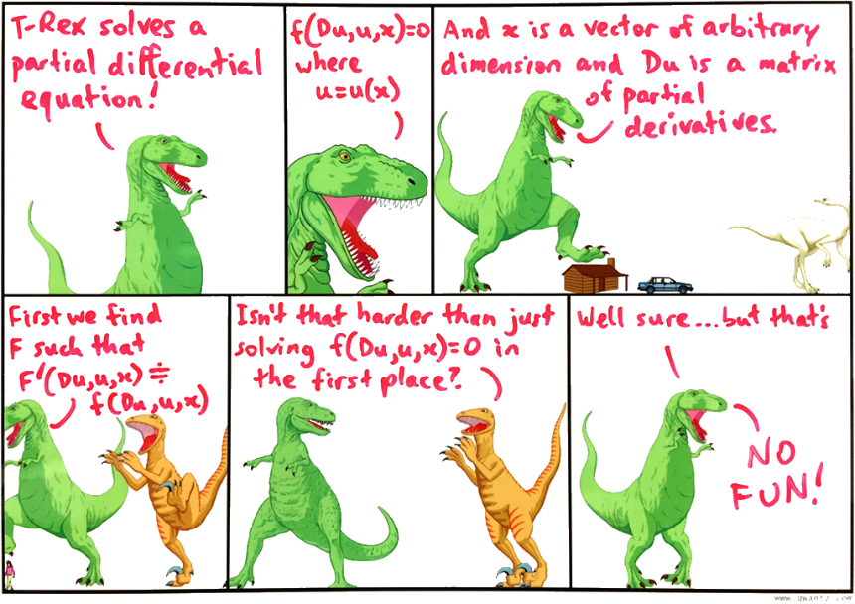
complicated to solve

