Colorado Technical University
Course: MATH207 – Integral Calculus

Unit 2 Part 4 Readings: Integration Techniques

Integration by Parts
A common student mistake is: ∫ƒ(x) g(x) dx = ∫ƒ(x) dx ˣ ∫ g(x) dx ← not true !

This would be too easy… therefore it is not true…
Remember when we did derivatives of multiples… it wasn't easy either

So… how do you solve integrals including multiplications ? (Yes… I know… fancy calculator…)

Suppose your calculator is dead or missing
Sometimes you can use a technique called Integration by Parts
This is just the product rule run backwards

How do you solve integrals including multiplications?
Given the integral: ∫ f(x) g(x) dx
1) Identify the two functions being multiplied: f(x) and g(x)
2) Make the function with the easiest antiderivative a derivative g’(x) or f’(x) and put it into the
“dv" slot. The other becomes “u”:
u = f(x)
dv = g’(x) dx
3) Take the derivative of f(x) and the integral of g’(x) dx (ignore the +c) to get:
du = f '(x) dx
v = ∫ g '(x) dx = g(x)
4) Use the formula: ∫ u dv = (u×v) – ∫ v du

BAD NEWS: Most of the time the integration by parts will not be enough to give you the answer after one shot. You may need to do some extra work: another integration by parts or use other techniques. (Like a fancy calculator or Wolframalpha…)

Integration by Trig Substitutions
These are used when an integral has a nasty divisor in it: ∫ dx /(a²–b²)
For a denominator of the form: a² − x², let x = a sin(θ) and use: 1 – sin²(θ) = cos²(θ)
For a denominator of the form: a² + x², let x = a tan(θ) and use: 1 + tan²(θ) = sec²(θ)
For a denominator of the form: x² − a², let x = a sec(θ) and use: sec²(θ) – 1 = tan²(θ)

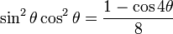
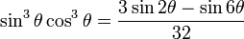
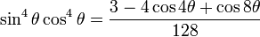
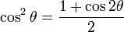
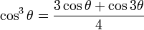
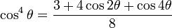
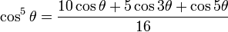
sin² θ + cos² θ = 1

1 + tan² θ = sec² θ

1 + cot² θ = csc² θ
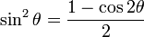
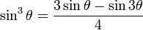
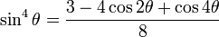
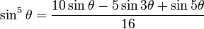

Integration by Partial Fractions
You can integrate any ratio of polynomials by expressing it as a sum of simpler fractions
Integration using partial fraction decomposition (abbreviated as PFD) is also known as partial
fraction expansion (abbreviated as PFE)
Partial fraction decomposition (PFD) is the “undo” of combining rational functions over a
common denominator

Partial Fractions (by Don Methven) http://www4.ncsu.edu/unity/lockers/users/f/felder/public/kenny/papers/partial.html
Partial fractions can be pretty tough to solve—especially if fractions are not your strong point.
Problems typically involve the splitting up of a single fraction into two or more fractions that each contain a single factor in the denominators (the bottom part of fractions).
Writing: $\frac{6}{x^{2}+2x-8} = \frac{1}{x-2}$ – $\frac{1}{x+4}$ means that you have expressed $\frac{6}{x^{2}+2x-8}$ in partial fractions.

Integration Using Partial Fraction Decomposition (PFD)
(also called Partial Fraction Expansion (PFE))

Partial fractions can be pretty tough to solve—especially if fractions are not your strong point

Problems typically involve the splitting up of a single fraction into two or more fractions that each contain a single factor in the denominators

Partial fraction decomposition (PFD) is the “undo” of combining rational functions over a common denominator.

Integration using partial fraction decomposition (abbreviated as PFD) is also known as partial fraction expansion (abbreviated as PFE).

The factors of the denominator determine the form of the response.

By using the technique of PFD, an extremely difficult integral can be made very simple to integrate.

The rational expression is resolved into separate terms, each defined by a factor of the denominator.

Integration by Numerical Methods
Most functions cannot be integrated
Computers can calculate statistical approximations in these cases
Popular techniques include:
Rectangles (using left-endpoint, right-endpoint or midpoint)
Trapezoids (using angled line segments)
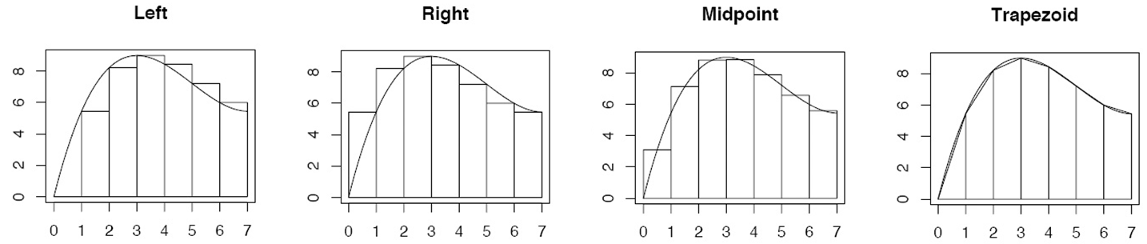
Simpson’s Rule (which uses parabolas rather than straight line segments

