**Colorado Technical University**

**Course:** MATH205 – Differential Calculus

## Unit 9 Part 18 Readings – Area Between Curves

**Area Between Two Curves**

The area under a curve is: A =*∫ab* *f* '(*x*) *dx*

We can use calculus to calculate the area between two curves using the areas beneath each

of the two curves

Suppose that *f* 'and *g*'are both continuous functions

Suppose also *f* '(*x*) ≥ *g*'(*x*) on the interval [*a*,*b*] (*f* 'is always above or equal to *g*')

The area between the two curves *f* 'and *g*'over the interval [*a*,*b*] is:

A =*∫ab* *f* '(*x*)  *g*'(*x*)*dx*

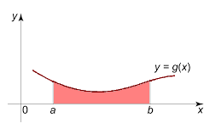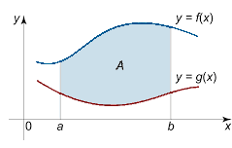

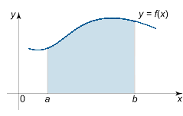

=  

The area between two curves = the area under the higher one  the area under the lower one

If you don’t know which curve is on top, pick one at random

If you get a negative answer, you picked the wrong one!

Just make your answer positive

If curves cross each other within the range you are interested in, you will have to calculate the

areas **piecewise**

#### The area between curves can be done “sideways”:

The b and a values will be values of y not x

The variable in the formula will be y not x

The differential will be dy not dx

