Colorado Technical University
Course: MATH205 – Differential Calculus

Unit 9 Part 17 Readings – Definite Integrals and

Area Under a Curve
Area Under a Curve
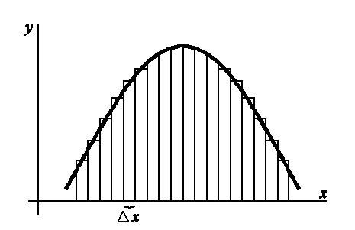
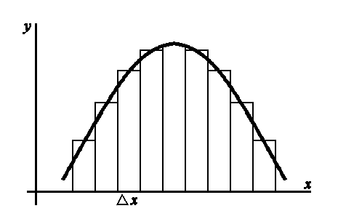
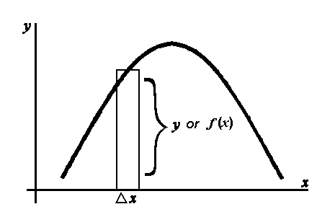
This is the geometric interpretation of an integral

The area A under a curve y = f(x) from x = a to x = b is
lim
n→∞
A = sum of the n rectangles between a and b
= ∫_{a}^{b} f ’(x) dx
b
a
= F(x) |
= F(b) − F(a)
where F(x) = ∫ f ' (x) dx

note: no constant of integration!

Definite Integral
If f (x) is a continuous function between x = a and x = b and the
derivative of F(x) is f ' (x) then
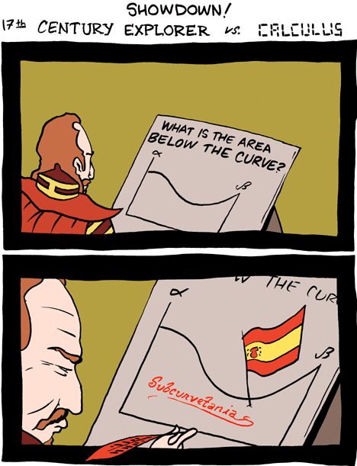
∫_{a}^{b} f ' (x) dx = F(b) − F(a
b
a
= F(x) |

Factoid: ∫_{a}^{b} f ' (x) dx = − ∫_{b}ª f ' (x) dx

