Colorado Technical University
Course: MATH205 – Differential Calculus

Unit 6 Part 12 Readings – Related Rates
Related Rates
In functions, changing one variable’s value changes the value of another variable that depends
on it
Problems including variables whose rates of change are related and can be modeled by an
equation are called related rates problems
One or more rates are given, and other rates are to be calculated using the equation
This can be done for any combination of variables in the model
Any others are considered to be constants

How to solve them:
1) Draw a picture
2) What are you trying to find?
3) Find an equation relating the variables
4) Find dy/dx (usually chain rule)
5) Plug in known values
6) Solve for the rate of change

2-D vs 3-D
If you take the derivative of a 3-dimensional thing, you get a 2-dimensional thing
If you take the derivative of a 2-D thing, you get a 1-D thing
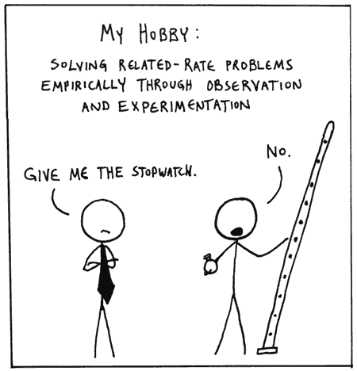
If you integrate a 2-D thing, you get a 3-D thing!

