Colorado Technical University
Course: MATH205 – Differential Calculus

Unit 4 Part 8 Readings – Higher Order Derivatives

Higher order derivatives
The first derivative of a function is denoted: y'
You can take a derivative of y’ denoted: y''
The derivative of y'' is y''' and so on
You can take as many derivatives of a function as the highest power of x in the y equation
Plus one more where the derivative is zero

Derivatives as Rates of Change
For location “s” at a given time, the function is called the position function
For movement over time t, the function becomes a displacement function: ∆s = f(a + ∆t) – f(a)
The average velocity between t₁ and t₂ will be: (f(t₂) – f(t₁))/(t₂ – t₁)
The first derivative of the position function is the speed function
The second derivative is the acceleration function
The third derivative is called the “jerk”

For growth models, the first derivative is the instantaneous rate of growth

These are all different ways to say the same thing:

instantaneous velocity exact rate of change
y'
derivative slope of a tangent line
$$\frac{dy}{dx}$$
$$\frac{∆y}{∆x}$$
lim
Δ x → 0
$$\frac{dy}{dx}$$
lim
dx → 0

Derivatives in kinematic physics
In most real-life situations, forces and accelerations are not fixed quantities but vary with time. Algebraic formulas can only approximate the situation, but calculus can give exact solutions.
If a function gives the position of something as a function of time, the first derivative gives its
velocity, and the second derivative gives its acceleration.
So, you differentiate position to get velocity, and you differentiate velocity to get acceleration.
s = ƒ(t) the position function
ƒ'(t) ds/dt velocity
ƒ''(t) d²s/dt² acceleration
ƒ'''(t) d³s/dt³ “jerk”
ƒ''''(t) d⁴s/dt⁴ “jounce” or “snap”
ƒ'''''(t) d⁵s/dt⁵ “crackle”
ƒ''''''(t) d⁶s/dt⁶ “pop”

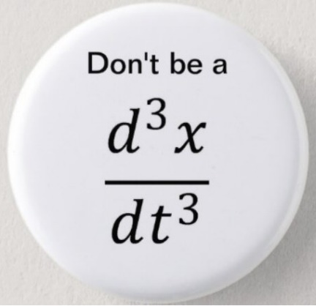

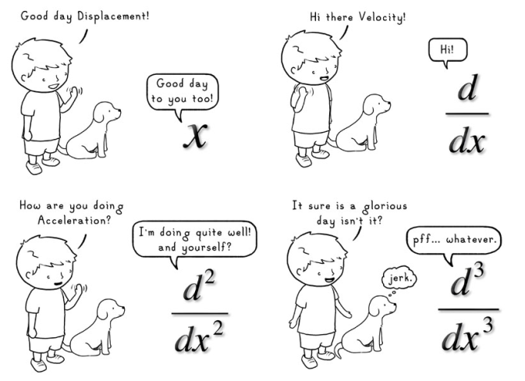

Derivatives in Engineering
If you have an energy function w
w'(t) = power
w''(t) = change in power

P = dW/dt Power is the time derivative of work
ω = dθ/dt Angular velocity
α = dω/dt Angular acceleration
τ = dL/dt Torque is the derivative of angular momentum
m d²x/dt² = -k x(t) A spring in simple harmonic motion
d²θ/dt² = -g/l θ(t) Equation of a pendulum, if θ is small such that sin(θ) ≈ θ

