Colorado Technical University
Course: MATH205 – Differential Calculus

Unit 2 Part 3 Readings: Modeling, and Transforming Functions

Mathematical Modeling
Functions are often used to model real-world phenomena
A mathematical model is a mathematical description (often by means of a function or
an equation) of a real-world phenomenon
The purpose of the model is to understand the phenomenon and often to make
predictions about future behavior (forecasts)
A mathematical model is never a completely accurate representation of a physical
situation
Unless it was developed as part of a scientific experiment to show the particular
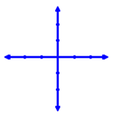
relationship, while it may be useful for forecasting, there is no scientific evidence
to show a particular model accurately explains a phenomenon
Linear Functions
Graphs are straight lines
Formula: y = ƒ(x) = mx + b
where m is the slope of the line and b is the y-intercept

Constant Function
ƒ(x) = c

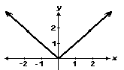

Identity Function Absolute Value
ƒ(x) = x ƒ(x) = |x|

Polynomial Functionss
A function P is called a polynomial if
P(x) = a_{n} x^{n} + a_{n−1} x^{n−1} + ⋯ + a₂ x² + a₁ x +​ a₀
where n is a nonnegative integer
and the numbers a₀, a₁, a₂,…, a_{n} are constants called the coefficients of the polynomial

Rational Functions
A rational function is a ratio of two polynomials:
ƒ(x) = P(x)/Q(x)

Power Functions
A function of the form ƒ(x) = xª, where a is a constant, is called a power function
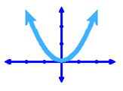
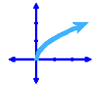
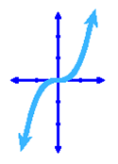
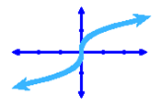
A fractional value of a will be a root function
Square
or
Quadratic
Square Root
Cube
Cube Root

Trigonometric Functions
For models, usually sine and cosine
These are used for real-life phenomena that are cyclical

Exponential Functions
Exponential functions are of the form ƒ(x) = a^{x}, where the base a is a positive constant
Logarithmic functions ƒ(x) = log_{a}x, where the base a is a positive constant, are the
inverse functions of the exponential functions

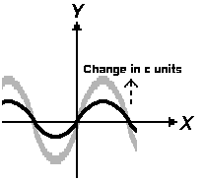
Transforming Functions
vertical shifts
y = ƒ(x) + c plus shifts up
y = ƒ(x) – c minus shifts down
vertical stretching & shrinking
if c>1 y = c ƒ(x)
stretches vertically
if 0<c<1 y = c ƒ(x)
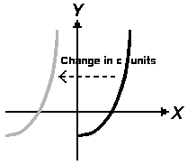
shrinks vertically

horizontal shifts
y = ƒ(x)
y = ƒ(x – c)
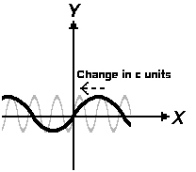
minus shifts right (counter-intuitive)

horizontal stretching & shrinking
if c>1 y = ƒ(cx)
shrinks horizontally
if 0<c<1 y = ƒ(cx)
stretches horizontally

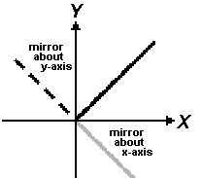
reflection
y = - ƒ(x)
reflects about the x-axis
y = ƒ(-x)
reflects about the y-axis

Inverse Functions
Inverse functions "undo" another function
The inverse is usually shown by putting a little "⁻¹" after the function name: ƒ ⁻¹(x)

