**Colorado Technical University**

**Course:** MATH116 – Foundations for Calculus

# Unit 10 Part 19 Readings: Polar Coordinates

**Polar graphs**

ordered pair *P* = (*r*, *θ*)

*r* is the distance (radius) from the pole

*θ* is an angle from the polar axis (degreesº or radiansπ)

*π*/12

0, 2*π*

*π*/6

*π*/4

*π*/3

5*π*/12

*π*/2

7*π*/12

2*π*/3

3*π*/4

5*π*/6

11*π*/12

*π*

13*π*/12

7*π*/6

5*π*/4

4*π*/3

17*π*/12

3*π*/2

19*π*/12

5*π*/3

7*π*/4

11*π*/6

23*π*/12

1

2

3

15º

0º, 360º

30º

45º

60º

75º

90º

105º

120º

135º

150º

165º

180º

195º

210º

225º

240º

255º

270º

285º

300º

315º

330º

345º

1

2

3

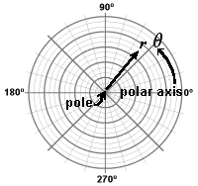

Positive angles are measured counterclockwise from the polar axis

Negative angles are measured clockwise from polar axis

*r* > 0 - point lies on the terminal side of *θ*

*r* < 0 - point lies along the ray opposite the terminal side of *θ*

*r* = 0 point lies on the pole irrespective of the value of *θ*

**Polar to rectangular point conversion**

*x* = *r* cos *θ* *y* = *r* sin *θ*

**Rectangular to polar point conversion**

*r* = $\sqrt{x^{2}+y^{2}}$*θ* = arctan (*y* ÷ *x*)

Plot the (x,y) value to find the quadrant so you know which arctan value to use

**Polar equations**

use variables *r* and *θ*

**Converting rectangular equations to polar equations**

replace *x* with *r* cos *θ* and *y* with *r* sin *θ*

**Converting polar equations to rectangular equations**

not easy; try:

*r* 2 = *x*2 + *y*2 *r* cos *θ* = *x* *r* sin *θ* = *y* tan *θ* = *y*/*x*

**Absolute value of a complex number** = distance between the point and 0:

| a + b*i* | =

**Polar form of a complex number**

z = *r* (cos *θ* + *i* sin *θ*)

*r* = $\sqrt{a^{2}+b^{2}}$*θ* = arctan(b/a)

sometimes called "trigonometric form"

**DeMoivre’s Theorem**

power of a complex number:

zn = [ *r* (cos *θ* + *i* sin *θ*)] n = *r* n(cos n*θ* + *i* sin n*θ*) n>0

<https://www.electronics-tutorials.ws/accircuits/complex-numbers.html>

In electrical engineering, to distinguish an imaginary number from a real number the letter “j” (known commonly in electrical engineering as the **j-operator)** is used. The letter “j” is placed in front of a real number to signify its imaginary number operation.

Complex numbers that are made up of real (the active component) and imaginary (the reactive component) numbers can be added, subtracted and used in exactly the same way as elementary algebra is used to analyze DC Circuits.

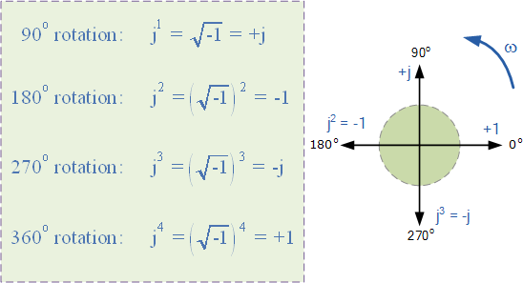The **j-operator** has a value exactly equal to √-1, so successive multiplication of “j“, ( j × j ) will result in j having the values of, -1, -j and +1. As the j-operator is commonly used to indicate the anticlockwise rotation of a vector, each successive multiplication or power of “j“: j2, j3 etc., will force the vector to rotate through a fixed angle of 90o in a counterclockwise direction. Likewise, if the multiplication of the vector results in a  -j  operator then the phase shift will be -90o, i.e. a clockwise rotation.

So by multiplying an imaginary number by j2 will rotate the vector by  180o anticlockwise, multiplying by j3 rotates it  270o and by j4 rotates it  360o or back to its original position. Multiplication by j10 or by j30 will cause the vector to rotate anticlockwise by the appropriate amount. In each successive rotation, the magnitude of the vector always remains the same.

In Electrical Engineering there are different ways to represent a complex number either graphically or mathematically. One such way that uses the cosine and sine rule is called the **Cartesian** or **Rectangular Form**.

## Complex Numbers using the Rectangular Form

In Phasors, we saw that a complex number is represented by a real part and an imaginary part that takes the generalized form of:

Z = x + jy

Where:   Z  -  is the Complex Number representing the Vector

  x  -  is the Real part or the Active component

  y  -  is the Imaginary part or the Reactive component

  j  -  is defined by √-1

In the rectangular form, a complex number can be represented as a point on a two dimensional plane called the **complex** or **s-plane**. So for example, Z = 6 + j4 represents a single point whose coordinates represent 6 on the horizontal real axis and 4 on the vertical imaginary axis.

### Complex Numbers using the Complex or s-plane

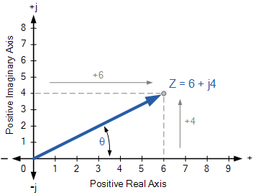

But as both the real and imaginary parts of a complex number in the rectangular form can be either a positive number or a negative number, then both the real and imaginary axis must also extend in both the positive and negative directions. This then produces a complex plane with four quadrants called an **Argand Diagram**.

### Four Quadrant Argand Diagram

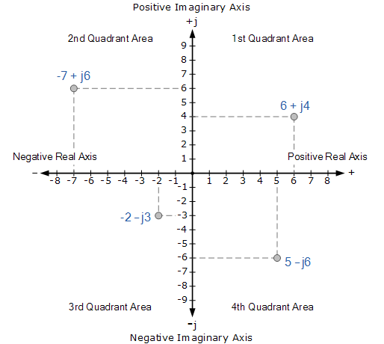

On the Argand diagram, the horizontal axis represents all positive real numbers to the right of the vertical imaginary axis and all negative real numbers to the left of the vertical imaginary axis. All positive imaginary numbers are represented above the horizontal axis while all the negative imaginary numbers are below the horizontal real axis. This then produces a two dimensional complex plane with four distinct quadrants labelled, QI, QII, QIII, and QIV.

The Argand diagram can also be used to represent a rotating phasor as a point in the complex plane whose radius is given by the magnitude of the phasor will draw a full circle around it for every 2π/ω seconds.

Then we can extend this idea further to show the definition of a complex number in both the polar and rectangular form for rotations of 90o:

0° = ± 360° = + 1 = 1∠ 0° = 1 + j**·**0

+ 90° = + $\sqrt{-1}$ = + j = 1∠ + 90° = 0 + j**·**1

– 90° = – = – j = 1∠ – 90° = 0 – j**·**1

± 180° = ()2 = – 1 = 1∠ ± 180° = – 1 + j**·**0



