## Analytic Trigonometry Unit 2 Readings:

## Trigonometry

## Trigonometric Functions – relationships among the lengths of sides of a right triangle

|  |  |  |  |
| --- | --- | --- | --- |
| **Function**  A  C  B  a  b  c  *θ*  Side adjacent to *θ*  Side opposite *θ*  Hypotenuse | Abbr | **Definition** | **Relation** |
| Sine | sin | sin *θ* = = | sin *θ* =  = cos (*θ* - 90°) |
| Cosine | cos | cos *θ* = = | cos *θ* =  = sin (*θ* - 90°) |
| Tangent | tan | tan *θ* = = | tan *θ* =  = |
| Cotangent | cot | cot *θ* = = | cot *θ* =  = |
| Secant | sec | sec *θ* = = | sec *θ* =  = csc (*θ* - 90°) |
| Cosecant | csc | csc *θ* = = | csc *θ* =  = sec (*θ* - 90°) |

In a circle, the tangent is: $\frac{rise}{run}$

**MOST IMPORTANT FACTOID: THE TANGENT IS A SLOPE**

Based on the Pythagorean Theorem *a*2 + *b*2 = *c*2,

where *c* is the hypotenuse and *a* and *b* are the other sides,

there are three identities:

**sin2 *θ* + cos2 *θ* = 1**

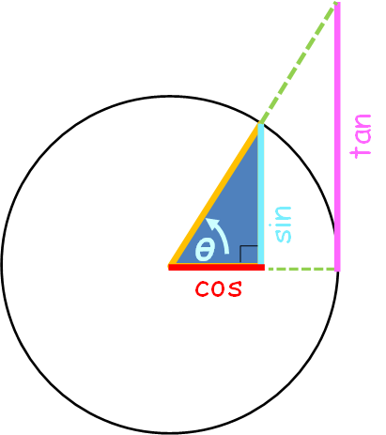**1 + tan2 *θ* = sec2 *θ***

**1 + cot2 *θ* = csc2 *θ***

## Circle showing the important trig functions:



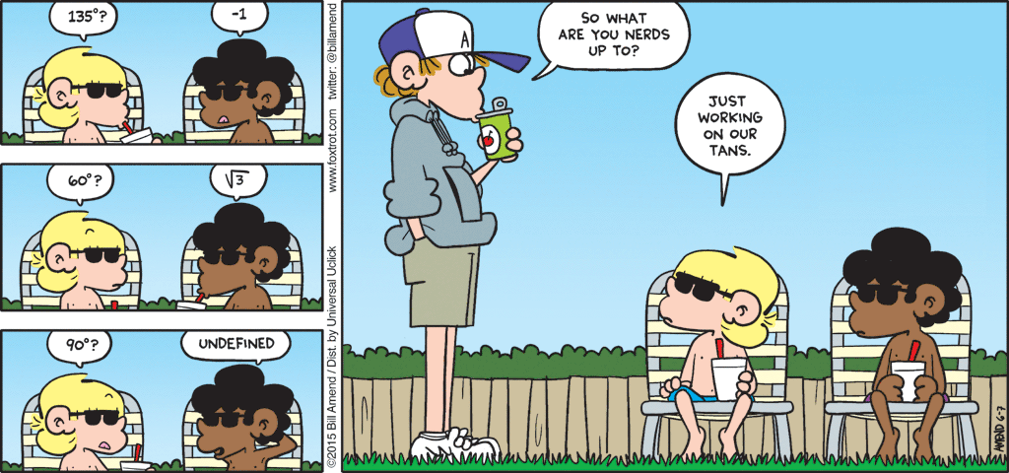

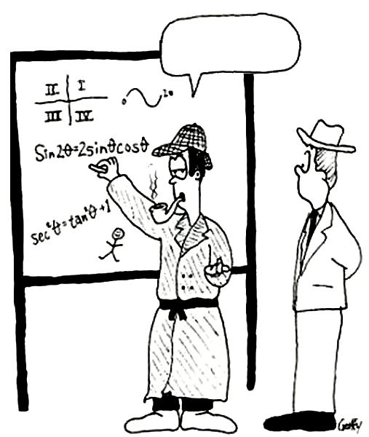

Trigonometry,

my dear Watson!

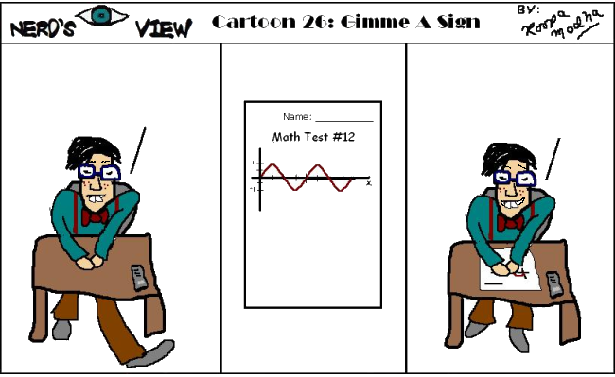

If she loves me, give me a sign!

A sine! So she

does love me!

Identify the

trig function