**Analytic Trigonometry Unit 02 Problems**

**Review**

1) The given angle 12° is in standard position.

III

IV

II

I

Determine the quadrant in which the angle lies:

a) I b) II

c) III d) IV

2) Classify the given angle: 175º

a) Acute b) Right c) Obtuse d) Straight

**Trigonometry**

**Hint**

sin(*θ*) = rise or . opposite .

hypotenuse hypotenuse

cos(*θ*) = run . or . adjacent .

hypotenuse hypotenuse

tan(*θ*) = rise or opposite

run adjacent

cot(*θ*) = run or adjacent

rise opposite

sec(*θ*) = hypotenuse or hypotenuse

run adjacent

csc(*θ*) = hypotenuse or hypotenuse

rise opposite

For the triangle shown, find:

a

b

1

20º

3) a =

4) b =

For the triangle shown, find:

6

8

10

*θ*

5) sin(*θ* ) =

6) cos(*θ* ) =

7) tan(*θ* ) =

8) cot(*θ* ) =

9) sec(*θ* ) =

10) csc(*θ* ) =

11) Simplify sin2 35º + cos2 35º

a) 2 b) 1

c) 3 d) 10

12) Which of the following expressions represents the same value as sin 19º?

a) cos 109º b) tan 19º

c) cos 289º d) csc 71º

**Elevations**

# Finding Points of Elevation

For surveyors, finding the elevation of points requires only

basic equipment

All elevation measurements involve three points:

- a reference point from which the elevation

measurement is being taken *(A),*

- the point of elevation being measured *(B),* and

- the point that lies directly below the point of

elevation being measured and that is on the

same plane as the point of reference (C).

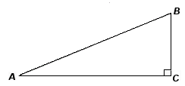

## 

## 13) Use the Pythagorean Theorem to determine the vertical

height between point *C* and point *B:*

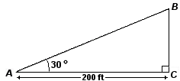14) Find the vertical distance between points *C* and *B* in the

elevation diagram:

**Capacitors and Inductors**

Due to their wave shape, sine and cosine functions are very common in electronics

An impedance triangle can be used to obtain the series equivalent for a parallel *RC* circuit

You need the total impedance, *Z*, and the phase angle, *θ*

The equivalent series values are: *R* = *Z* cos *θ* (in Ω)

*X* = *Z* sin *θ* (in Ω)

The impedance *Z* of a parallel *RC* circuit is 10kΩ

The phase angle *θ* is 26°

Convert to an equivalent series circuit

15) *R* =

16) *X* =

**Image Rotation**

The 2D point (*x*, *y*) is to be rotated counterclockwise by the angle *θ*

(*x′*, *y′*) are the coordinates of the point after rotation

The formulas for *x′* and *y′* are:

x' = x cos*θ* – y sin*θ*

y' = x sin*θ* + y cos*θ*

x ′ = x cos ⁡ θ − y sin ⁡ θ y ′ = x sin ⁡ θ + y cos ⁡ θ . {\displaystyle {\begin{aligned}x'&=x\cos \theta -y\sin \theta \\y'&=x\sin \theta +y\cos \theta .\end{aligned}}}

17) When you rotate the point (7.3, 12.2) by 31 degrees, (x’, y’) =

18) When you rotate the point (-2.7, -46.1) by -48 degrees, (x’, y’) =

**Height of Impact** From : Proceedings of the AMATYC 32nd Annual Conference, Cincinnati, Ohio, 2006, pp.206-236.

American Mathematical Association of Two Year Colleges, http://www.amatyc.org

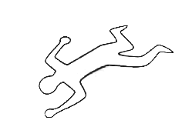The wife of the victim said that she had just asked

him for a divorce when he suddenly pulled

a .357 out of his jacket pocket and shot

himself in the head

According to her statement, he was standing

beside the kitchen sink at the time of

the shot

The victim has a single, near-contact

entrance wound above his right ear

67'' above his heel

The shot did not exit

Determine the height of impact to determine if the wife is telling the truth or not

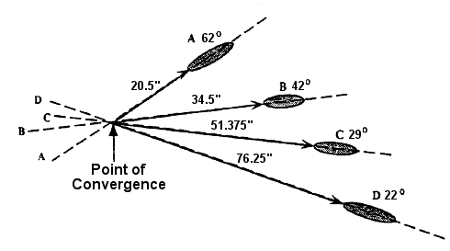

The investigator needs to:

Determine the **angle of impact**

***θ*** for each bloodstain

Measure the **distance D** from

the base of each stain

to the projected point of

convergence

Calculate the **height of impact**

height of tangent of the distance to the

impact = angle of impact × point of convergence

**H *θ D***

Find the average height for all

of the bloodstains

**Example:**

For bloodstain A in the example:

- The angle of impact *θ* is 62 degrees

- The distance from the base of stain A to the point of convergence is 20.5 inches

Substituting into the equation:

Height = (tangent of the angle) × (Distance)

We now have:

Height = (tangent of 62°) × (20.5 inches)

The tangent of a 62 degree angle is 1.8807265 (found using a calculator)

Plugging in this value, we now have:

Height = (1.8807265) (20.5 inches)

19-26) Fill in the following table to answer the problem question:

**Trigonometric Height of Impact Worksheet**

|  |  |  |  |  |
| --- | --- | --- | --- | --- |
| **STAIN** | **Angle**  **of Impact *θ*** | **tan(*θ*)** | **Distance (D) to Point of Convergence** | **(D) $×$ tan(*θ*)** |
| A | 62º |  | 20.5" |  |
| B | 42º |  | 34.5" |  |
| C | 29º |  | 51.375" |  |
| D | 22º |  | 76.25" |  |

27) Sum of (D) * tan(*θ*) values =

28) Number of stains =

29) Height of impact =  =

30) If the victim's ear was 67'' above the floor, was the wife telling the truth? Explain your

answer!

**Extra credit:**

20.5"



Remember, the tangent is the rise (sin) over the run (cos)

H in this exercise is the: rise run (mark one)

D in this exercise is the: rise run (mark one)

What would the tangent have to be for H to be 67 inches?

Remember, the tangent is a slope

Will this slope be steeper or less steep than was observed at this crime scene?