**Colorado Technical University**

**Course:** MATH366 – Probability and Statistics

#### Unit 9 Part 17 Readings: Continuous Probability,

#### the Normal Distribution

##### **Continuous Probability**

##### **Continuous probability distribution:** A probability distribution in which the random

##### variable X can take on any value (is continuous)

##### A continuous distribution has a range of values that are infinite, and therefore

##### uncountable

##### **Continuous Uniform Distribution**

##### The uniform distribution has both continuous and discrete forms

##### Values of the random variable have equal probabilities of occurring

##### **Probability in a normal distribution**

**standard normal distribution** - centered at 0 with a standard deviation of 1

z-scores -convert any normal distribution to a standard normal

z = $\frac{value-mean}{standard dev}$ = $\frac{x - μ}{σ}$

#### The normal distribution is completely defined by µ and σ

#### Example of a normal distribution

#### with µ = 66 and σ = 3.4

#### Approximate values of the normal distribution

#### (for this class):

#### Note: these are not exact – more accurate values can be found using Excel

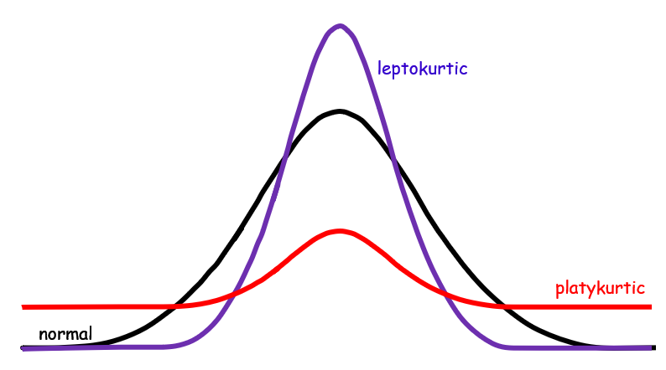**Non-normal distributions**

**Kurtosis** - how tall or flat your curve

is compared to a normal

curve

Curves taller than a normal

curve are called

"Leptokurtic"

Curves that are flatter than a

normal curve are called

"Platykurtic"

**Skewness** – the data are “bunched” to one side

vs a normal curve

Scores that are "bunched" at the right or high end

of the scale are said to have a “negative skew”

In a “positive skew”, scores are bunched near the left or low end of a scale

