Colorado Technical University
Course: MATH366 – Probability and Statistics

Unit 3 Part 05 Readings: Central Tendency,

Variability, and Multiple Comparison Charts

Descriptive statistics - describe the sample
Observation - a member of a data set
Sample size - the total number of observations in your sample
Maximum and minimum values
Sample size - the total number of observations in your sample

Averages "Measures of Central Tendency"
Where the data "tend to center"
Remember Σ means "sum of "
≡ means "is defined to be"
mean ≡ Σ (observations)
# observations
called "μ" for a population "x̄" for a sample
The sample mean x̄ is our best estimate of the (unknown) population mean μ
note: to get the x̄ symbol in Word, you need to type: x ALT+0772

median => list all observations lowest to highest
the median is the middle value in the list (for an odd # of observations)
the median is the mean of the two middle values in the list (even #)

mode ≡ the most common observation (may be more than one)

midrange ≡ max + min
2

Measures of Variability

While an average tells you where the data in your sample tend to pile up, how much they spread out from that center is also critical
range ≡ max –min

interquartile range ≡ 3rd quartile value – 1st quartile value “IQR”

range rule of thumb ≡ (max – min)/4

deviation ≡ each obs – mean

population variance ≡ Σ (deviations)² called "σ²" "sigma-squared"
# observations

sample variance ≡ Σ (deviations)² called "s²"
# observations - 1

population standard deviation ≡ called "σ " "sigma"

sample standard deviation ≡ called "s"

Outliers can really affect your statistics!

For a graph showing both averages and the variability of the data use a:
Multiple Comparison Chart

Multiple Comparison Charts
These graphs allow the viewer to see the differences in a continuous (measured or counted)
variable between qualitative groups
Sort of a boxplot comparison for measurement data
These are done using the Excel "High-Low-Close stock chart
Groups are different if their whiskers don't overlap (there is no box in this type of plot)
We start by using the maximum, minimum and median, but we will be using these graphs
for a variety of things using a variety of variables as the course progresses
Using the maximum and minimum will mean we can find fewer different groups
Later versions of the Multiple Comparison Graph will eliminate this problem

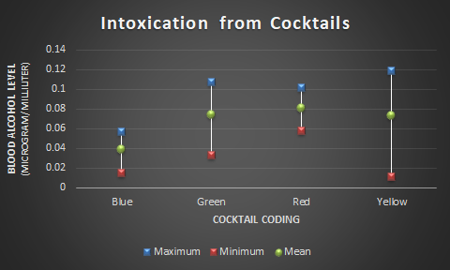

Adding the Analysis ToolPak in Microsoft Office Excel
Click on the 'File' button at the top left of the screen
At the bottom of the drop down menu, click on the 'Excel Options' button
The Excel Options window will open
In the column on the left, click on the 'Add-Ins' heading
Click the 'Go' Button - an 'Add-Ins' window will open.
Click in the checkbox next to 'Analysis ToolPak'
Click the 'OK' button
When it is finished, click on the 'Data' tab
The Analysis group will be on the right side of the ribbon
If “Data Analysis” is not there, your installation of the ToolPack didn’t work

