Colorado Technical University
Course: MATH207 – Integral Calculus

Unit 9 Part 18 Readings: Polar Calculus

Polar Derivatives
Find the slope of a polar curve
Remember, a slope will be: $\frac{\text{dy}}{\text{dx}}$
x = r cos(θ)
Use: r = ƒ(θ)
Then: x = ƒ(θ) cos(θ)
So: $\frac{\text{dx}}{\text{dθ}}$ = ƒ ’(θ) cos(θ) - ƒ(θ) sin(θ)
= $\frac{\text{dr}}{\text{dθ}}$ cos(θ) - r sin(θ)
And: y = r sin(θ)
Then: y = ƒ(θ) sin(θ)
So: $\frac{\text{dy}}{\text{dθ}}$ = ƒ ’(θ) sin(θ) + ƒ(θ) cos(θ)
= $\frac{\text{dr}}{\text{dθ}}$ sin(θ) + r cos(θ)
So: $\frac{\text{dy}}{\text{dx}}$ = $\frac{\text{dy}\text{/}\text{dθ}}{\text{dx/}\text{dθ}}$ = $\frac{\frac{\text{dr}}{\text{dθ}}\text{ sin(θ) + r cos(θ) }}{\frac{\text{dr}}{\text{dθ}}\text{ cos(θ) - r sin(θ) }}$
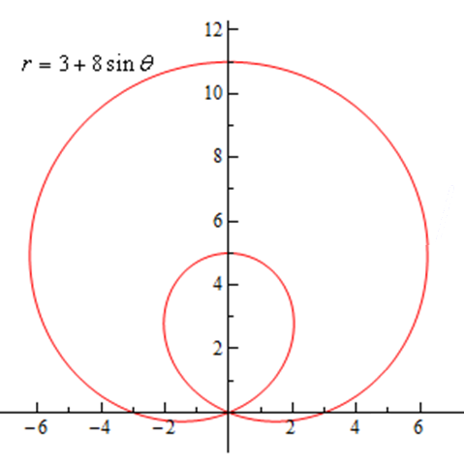
Polar Integrals
Can we find areas enclosed by polar curves?
Note that I said “enclosed by” instead of “under”
These problems work a little differently for
polar coordinates
You need to know which part of the graph you want to find
the area of – the inner loop? The outer loop?
https://www.geogebra.org/m/jhKUc6Hm
will let you see where the graph starts and which
way it goes
this will be necessary for the limits of the integral
The formula for finding this area is: A = ∫_{α}^{β} 1/2 r² dθ
Notice that we use r in the integral instead of ƒ(θ)

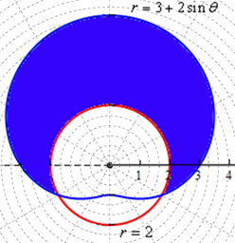
Area Between Two Polar Curves
The formula for finding this area is: A = ∫_{α}^{β} 1/2 (r_{outer}² - r_{inner}²) dθ
It’s hugely critical to get the “inner” and “outer” right!
The limits will be where you need this

