**Colorado Technical University**

**Course:** MATH207 – Integral Calculus

#### Unit 8 Part 16 Readings: Approximation Series

Arithmetic series, geometric series, another is the:

**Power series:** a0 +a1u + a2u2 + a3u3 + … + anun

u will be a function of x

Often generated by long division

May converge for all values of x, for no values of x or converge for

some and diverge for other values of x

Tests for convergence: ratio, comparison

You need series for common electronic functions such as: e 1 cos ωt root (1+Q)

**Maclaurin Series**

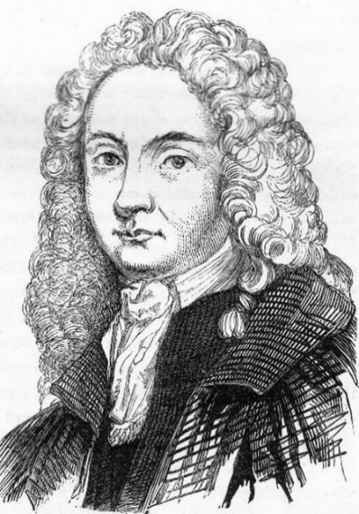Start with a power series: *f* (x) =a0 +a1x + a2x2 + a3x3 + …

Need to find the values for a0 a1 a2 …

Let x = 0

*f* (0) =a0 +a10 + a202 + a303 + … = a0

the value the function has at x = 0 is the value for a0

To find a1, take the first derivative: *f* ' =a1 + 2a2x + 3a3x2 + …

Again, let x = 0: *f* ' (0) =a1 + 2a20 + 3a302 + … = a1

the value *f* ' has at x = 0 is the value for a1

*f* ' ' =2a2 + 6a3x + 12a4x2 + …

*f* ' ' (0) = 2a2 + 6a30 + 12a402 + … = 2a2

a2 = *f* ' '/2

And so on: an = *f* nth deriv / n!

The complete series is:

*f* (x) =*f* (0) + *f* '(0) x + *f* ' '(0) x2/2 + *f* ' ' '(0) x 3/3! + *f* ' ' ' '(0) x 4/4! …

called the **Maclaurin series** **Colin Maclaurin**

## Maclaurin series of some common functions

Finite geometric series:



Infinite geometric series:



Variants of the infinite geometric series:



Square root:



Binomial series

(includes the square root for *α* = 1/2 and the infinite geometric series for *α* = −1):



with generalized binomial coefficients



Exponential function:



Natural logarithm:



Trigonometric functions:



where the *Bs* are Bernoulli numbers.





Hyperbolic functions:

