**Colorado Technical University**

**Course:** MATH207 – Integral Calculus

#### Unit 5 Part 10 Readings: Higher Order Integrals

**Higher-Order Integrals**

With functions of one variable we integrated over an interval (a one-dimensional space)

When integrating a function of two variables we will integrate over a region

Do the integrations in-order , inside first then outwards, outside one last

Frequently not all the same variable

Frequently use functions of variables for the limits

**Volumes**

This leads to a volume:

v = *∫∫*ƒ(x,y) dA

**Example:**

Use double integrals to find the volume of a tetrahedron

bounded by the planes:

(x=0, y=0, z=0), and the plane: 2x + y + z = 2

1) solve for z: z = 2 – 2x – y

2) set z=0 and solve for y: y = –2x + 2

3) this is a line where the y-intercept is 2

4) find the x-intercept (where y=0) = 1

5) V = *∫*01 *∫*0–2x+2 (2–2x–y) dy dx

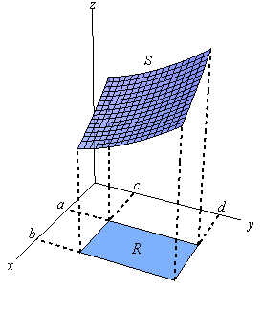**Area under a curve**

The area under a curve ƒ(x) between two points a & b on the x-axis is:

Area = *∫* ab ƒ(x) dx

but ƒ(x) = *∫* 0ƒ(x) dy

so Area = *∫*ab *∫*0ƒ(x) dy dx

**Averages**

If the class scores on a quiz are: 10, 9, 10, 8, 6, 5

then the average score is the sum divided by the number:

10+9+10+8+6+5 48

= = 8

6 6

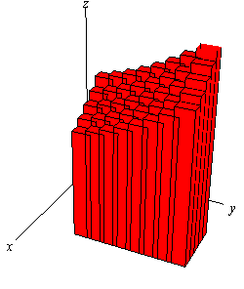Suppose that between t = 0 and t = 1 the speed of an object is sin(πt)

What is the average speed of the object over that time?

Average speed = *∫*01 sin(πt) dt