Colorado Technical University
Course: MATH207 – Integral Calculus

Unit 4 Part 07 Readings: Surface Area and Growth Models

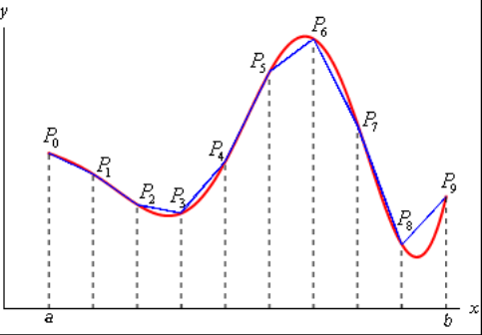
Surface Area
Arc (Curve) Length - to determine the length of a continuous
function y=ƒ(x) on the interval [a,b]:
1) divide the interval up into equal subintervals each
of width Δx
2) approximate the curve by a series of straight lines
connecting the points
3) the length of the curve can be estimated by the sum
of the lengths of the lines
The length of each line is: $\sqrt{\left({\text{x}}_{\text{i}}\text{-}{\text{x}}_{\text{i-1}}\right)\text{2}\text{+}\left({\text{y}}_{\text{i}}\text{-}{\text{y}}_{\text{i-1}}\right)\text{2}}$ =$\sqrt{\text{Δx}\text{2}\text{+Δy}\text{2}}$
As Δx→0, the length of the curve “S” becomes: S = ∫ _{a}^{b} $\sqrt{\text{1+(dy/dx)}\text{2}}$ dx
The surface area of a solid of revolution follows a similar pattern, but we rotate the lines around the appropriate axis
These rotated sections are called “frustums”
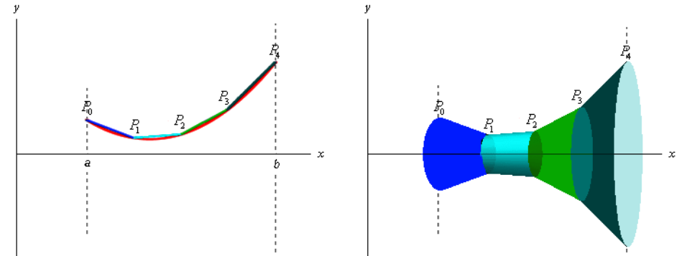

The surface area of a frustum is: A = 2πrL

where r=½(r₁+r₂)

r₁ = radius of right end

r₂ = radius of left end

and L is the length of the frustum

The surface area over the interval is: S = ∫_{a}^{b} 2πy ds

where ds = $\sqrt{\text{1+}{\text{(dy/dx)}}^{\text{2}}}$ dx

for rotations around the x-axis

And S = ∫_{c}^{d} 2πx ds

where ds = $\sqrt{\text{1+}{\text{(dx/dy)}}^{\text{2}}}$ dy

for rotations around the y-axis

Units:

What are the units for the area problems? Units squared

What are the units for the volume problems? Units cubed

Growth Models
Exponential Models Logarithmic Models
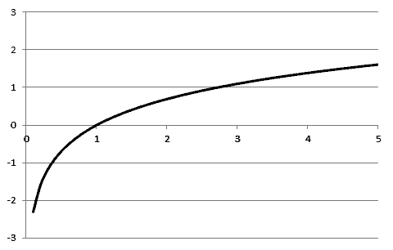
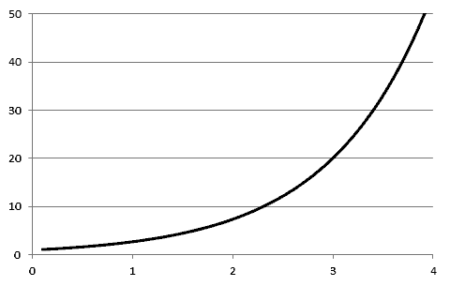

Start slow then speed up Start fast then slow down

Compound Interest: A = P(1+r/n)^{nt}
A = accumulated value
P = the principal amount of money
t = years
r = annual percentage rate (in decimal form)
n = compounded n times per year

Population Growth: A = A₀ e^{kt}
A = amount at time t
r = growth rate
A₀ = original amount
if k > 0 then the population is growing
if k < 0, then the population is shrinking

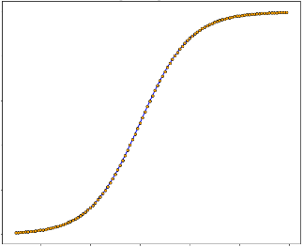
Logistic Growth (growth within a limit): A = c/ (1+ ae^{-bt})
c > 0
b > 0
as time t increases:
ae^{-bt} approaches 0
A gets closer to the limit c

Min + (Max-Min)/(1+e^(-rate*(day-inflexion pt)))

