Colorado Technical University
Course: MATH116 – Foundations for Calculus

Unit 6 Part 11 Readings: Composites, One-to-One, Inverses

Composite functions
Have an order - the output of g(x) is the input to ƒ(x)
New symbols: ƒ ○ g ƒ of g ƒ(g(x))
the composition of the function f with g is the
composite of ƒ with g
ƒ ○ g ≠ g ○ ƒ
Just plug the "inside" function into the "outside" function
One-to-One Functions
A function is one-to-one if any two different inputs in the domain correspond to two
different outputs in the range
A function is not one-to-one if two different inputs correspond to the same output.
Horizontal-Line Test - If every horizontal line intersects the graph of a function in at
most one point, then f is one-to-one
Warning: in other disciplines, there is a special line called the 1:1 line (pronounced
one-to-one) which has a slope of 1 (where y=x)
In Math we call this the “identity line” or “line of equality”
Inverse Functions - Undo a function
Definition of the inverse of a function:
If ƒ(g(x)) = x for every x in the domain of g and g (ƒ(x)) = x for every x in the domain of ƒ the function g is the inverse of ƒ
Denoted ƒ^{–1}
The domain of f is equal to the range of ƒ^{–1} and vice-versa

Finding the inverse of a function
1) Replace "ƒ(x)" with "y"
2) Interchange "x" and "y"
3) Solve for "y"
If the resulting equation does not define "y" as a function of "x", then ƒ does
not have an inverse
If the resulting function does define "y" as a function of "x", then ƒ does have
an inverse
4) If ƒ does have an inverse, replace "y" in step 3 with ƒ^{–1}
- Check to ensure ƒ(ƒ^{–1}(x)) = x and ƒ^{–1}(ƒ(x)) = x
Because the domain of ƒ is equal to the range of ƒ^{–1} and vice-versa, an inverse will
rotate a function about the identity line:
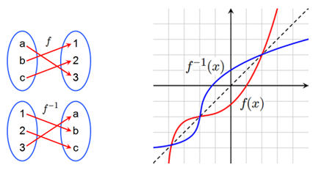

Horizontal Line Test for an inverse function:
If a function has a horizontal line that intersects the function at two or more points, it
cannot have an inverse that is a function (because that would mean it couldn't
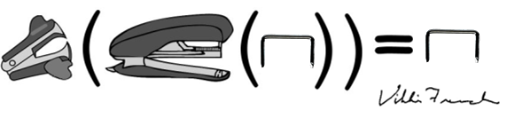
pass the vertical line)

