Colorado Technical University
Course: MATH116 – Foundations for Calculus

Unit 2 part 04 Readings: Real and Complex Zeros

Review of Complex numbers
remember:
≡ means "is defined to be"
"imaginary" unit i ≡ $\sqrt{-1}$
complex numbers have a real and an imaginary part: a + bi
every real number is a complex number in which the imaginary part equals zero

usually designated "z"
Rules for complex numbers:
equality: a + bi = c + di if a=c and b=d
addition: (a + bi ) + (c + di) = (a + c) + (b + d) i
subtraction: (a + bi ) – (c + di) = (a – c) + (b – d) i
complex conjugate: (a + bi ) × (a – bi) = a ²+ b ²
For $\sqrt{-n}$ ALWAYS TAKE OUT THE “i ” first!
$\sqrt{-4}$ = i $\sqrt{4}$ = 2 i
$\sqrt{-9}$ × $\sqrt{-36}$ = 3i × 6i = 18i² = –18 (the right answer)
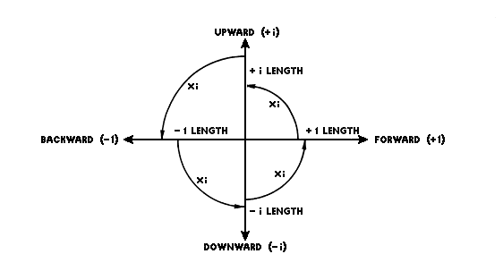
If you don’t take out the “i ” first:
$\sqrt{-9}$ × $\sqrt{-36}$ = $\sqrt{324}$ = 18 (the wrong answer)

The Complex Plane
imaginary unit i = $\sqrt{-1}$
i = $\sqrt{-1}$
i ² = –1
i ³ = – i
i ⁴ = 1
i ⁵ = i
.
.
.
complex numbers can be plotted
as points on the complex plane
real axis (horizontal) and an
imaginary axis (vertical)

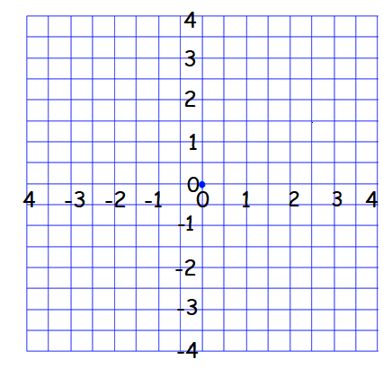
Graphing Complex Numbers
i
–2+i
1.5–2.5i
2+3i
We call the graph paper the "complex plane"
Given a complex number, to represent its components:
Move along the horizontal axis the amount of the real part
Move parallel to the vertical axis the amount of the imaginary part
Plot the point

Complex Numbers in Electronics
A common situation in electrical networks is the existence of many sine-shaped waves all with
the same frequency but with different amplitudes and phases
They are represented by a real multiplier for frequency and time and a complex multiplier for
amplitude (phasor)
Combining these phasors is called phasor arithmetic

In AC circuits, resistors, capacitors, and inductors can be combined in a single complex
number called the impedance (in ohms, Ω):
Z = R + j·X
R is the resistance (a real number)
X is the reactance (imaginary)
These are generally written:
Z = (17 + j·1.5)Ω
The imaginary unit, i, is represented by the letter "j", to avoid confusion with current (Ɪ )
If two impedances are connected in series, the equivalent impedance is obtained by addition:
Z_{e}= Z₁ + Z₂
The total impedance z_{T} in a parallel circuit composed of circuits z₁ and z₂ is given by the formula: z_{T} = $\frac{z_{1}z_{2}}{z_{1}+z_{2}}$
Kirchhoff's circuit laws (you will be running into them in your electrical engineering courses) work with phasors in complex form

