Analytic Trigonometry Unit 10 Readings:
Vectors

Vector quantities "vectors" - both magnitude and direction (N 5 mph)
Scalar quantities "scalars" - only magnitude (5 mph)
Directed line segment - from initial point to terminal point PQ
Magnitude = length || PQ || = distance from P to Q
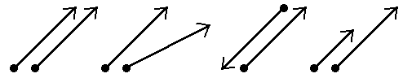
Vectors denoted by boldface letters: v w

v = w same magnitude same magnitude different magnitude
different direction opposite direction same direction
Magnitude of a vector v (distance between initial point (x₁,y₁)
and terminal point (x₂,y₂): || v || = $\sqrt{{\left(x_{1}-x_{2}\right)}^{2 }+ {\left(y_{1}-y_{2}\right)}^{2 }}$

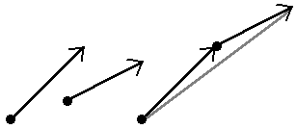
Direction can be shown by slope: m = $\frac{y_{1}-y_{2}}{x_{1}-x_{2}}$ if $x_{1}-x_{2}$≠0
Scalar multiplication kv: positive real number changes the
magnitude |k| ||v|| but not the direction; negative points
it in the opposite direction
Vector addition u + v

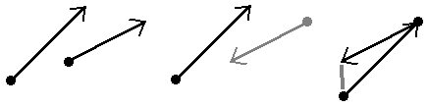
Vector subtraction u - v

Plotting vectors
vector i is the unit vector whose direction is along the positive x-axis
vector j is the unit vector whose direction is along the positive y-axis
vector v from (0,0) to (a,b): v = a i + b j
a and b are the scalar components of v
a is the horizontal component, b is the vertical component
v = a i + b j is a linear combination of i and j
||v|| =
Scalar multiplication:
kv = (ka) i + (kb) j
Position vector –
if v doesn't start at (0,0):
v = (x₂ – x₁) i + (y₂ – y₁) j
Writing a vector in terms of its magnitude and direction
magnitude ||v|| direction angle θ
v = ||v|| (cos θ i + sin θ j)

The Dot Product - multiplying two vectors
v = a₁ i + b₁ j
v ● w = a₁ a₂ + b₁ b₂

w = a₂ i + b₂ j

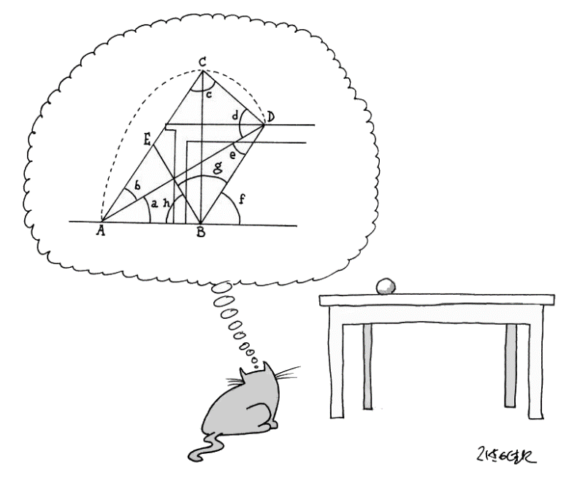

Vectors
compute properties of a vector
vector {2, -5, 4}
specify a vector as a linear combination of unit vectors
vector 3i + 5j
vector 2i - 4j + 3k

Vector Algebra
do vector computations
vector (1,3,-1) + (-2,1,6)
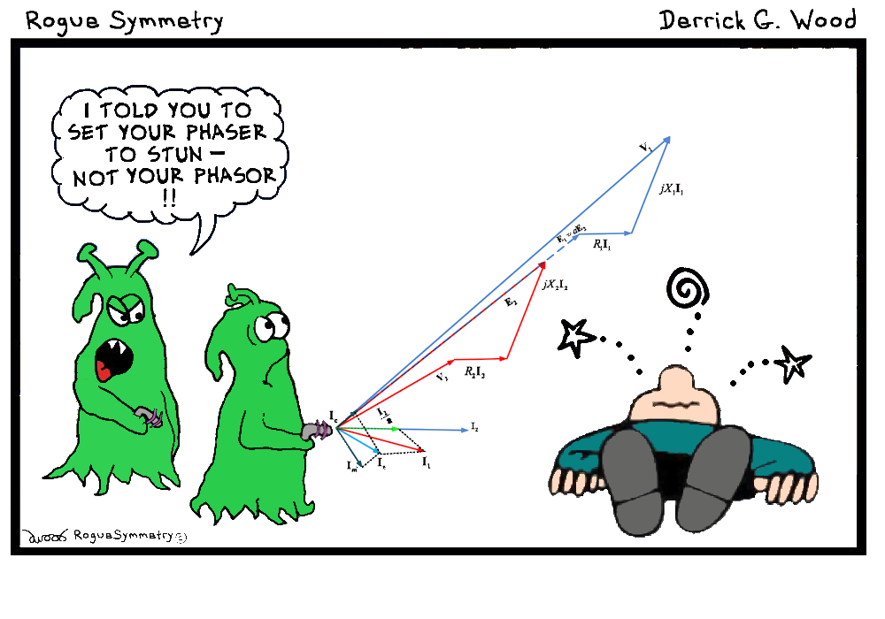
7 {1, 0, -2, 1} - 4 {2, -1, 1, -1}
(i + j + k) + (2i - 3j + 8k)
compute a dot product
{12, 20} . {16, -5}
(7i-j+3k).(4i-2k)

