**Analytic Trigonometry Unit 07 Problems**

**Hint**

sin(*θ*) = rise or . opposite .

hypotenuse hypotenuse

cos(*θ*) = run . or . adjacent .

hypotenuse hypotenuse

tan(*θ*) = rise or opposite

run adjacent

cot(*θ*) = run or adjacent

rise opposite

sec(*θ*) = hypotenuse or hypotenuse

run adjacent

csc(*θ*) = hypotenuse or hypotenuse

rise opposite

**Trigonometry**

1) For the triangle shown, calculate:

a

b

1

75º

a =

2) For the triangle shown, calculate:

.8506

.5258

1

*θ*

tan(*θ* ) =

3) Simplify sin2 (10π/9) + cos2 (10π/9)

a) 1 b) 9

c) 10/9 d) 10

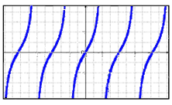4) Identify the type of trig graph:

a) sin b) cos

c) tan d) cot

e) sec f) csc

**Degrees and Radians**

5) Convert 24º to radians

**Degrees to Radians** multiply degrees by: 

**Radians to Degrees** multiply radians by: 

6) Convert π/12 to degrees

**Transforming Graphs**

**18**

**9**

π

2π

-π

-2π

**0**

**- 9**

**0**

7) What is the amplitude of the graph?

a) 36

b) 18

c)2𝜋

**- 18**

d) 𝜋

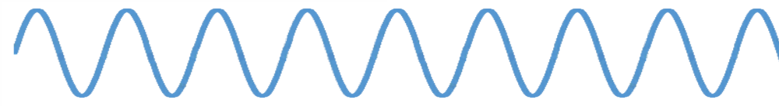

π

2π

-π

-2π

**0**

**1**

**0.5**

**-0.5**

**0**

**- 1**

8) What is the period of the graph?

a) 1

b) 2

c)𝜋

d) 2𝜋

9) The period of a transformed sine function is 5𝜋/3. What is the frequency?

**RC Circuit Analysis**

**Impedance**

Z = $\sqrt{R^{2}+{X_{C}}^{2}}$

**phase angle**

*θ* = tan-1

R

XC

25Ω

45Ω

~

VS

10) Calculate the impedance of the RC circuit:

11) Calculate the phase angle of the RC circuit:

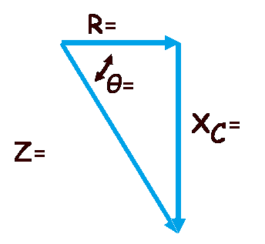12) Fill in the impedance triangle values:

**Area of an Oblique Triangle**

13) Calculate the area of a triangle with two sides 9 yards and 8 yards and an included

angle of 15° (don't forget the units!)

**Heron’s formula**

14) Calculate the area of a triangle with a = 10ft, b = 9ft, and c = 8ft (don't forget the units!)

**Law of Sines and Cosines**

$\frac{a}{sinA}$ = $\frac{b}{sinB}$ = $\frac{c}{sinC}$

or

$\frac{sinA}{a}$ = $\frac{sinB}{b}$ = $\frac{sinC}{c}$

Note: not drawn

to scale

A

B

C

a

b

c

15) Given B = 75º

b = 14 in

c = 9 in

calculate angle C to the nearest degree:

16) Given a = 15 mm

b = 20 mm

A = 40º

Calculate if there is:

a) One triangle b) Two triangles c) No triangles

17) Given that A = 75º

*a*2 = *b*2 + *c*2 – 2*bc* cos*A*

*or*

*b*2 = *a*2 + *c*2 – 2*ac* cos*B*

*or*

*c*2 = *a*2 + *b*2 – 2*ab* cos*C*

b = 14"

c = 9"

What is angle C?

**Complex Numbers**

18) *i* equals:

1. b) 0 c) –1 d) an irrational number

19) The real part coefficient of 6 – 4*i* is:

a) 6, –4b) 6 c) 2d) –4

20) The imaginary part coefficient of 6 – 4*i* is:

a) 6, –4b) 6 c) 2d) –4

21) Write in standard form: (7 – 2*i*) + (10 + 8*i*)

a) 17 – 10*i* b) –3 + 6*i* c) 17 + 6*i* d) –3 – 10*i*

22) *i* 2 equals:

a) –1 b) 1 c) 0 d) unknown, it’s a variable

23) Write in standard form: *i* (5*i* – 3)

a) 5*i* – 3*i*2 b) 2 c) 5*i*2 – 3*i*d) –5 *–* 3*i*

24) Write in standard form: $\sqrt{-75}$ $\sqrt{-75}$

a) 75 b) – 75 c) – 75*i* d) 75*i*2

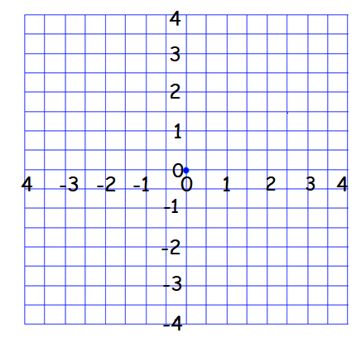

b

a

c

d

25) Which point shows the graph of 3.5 – 2*i*:

a) b) c)d)

Remember, in electronics, the imaginary part is

usually represented by "*j* " rather than "*i* " to avoid

confusion with current "*I* ".

26) The impedance in one component of an AC series

circuit is z1 = 2 + *j*·6 ohms, and the

impedance in another component of the circuit is

z2 = 5 - *j*·3 ohms. The total impedance zT

for a series circuit is the sum of the impedances for

its individual components:

zT = z1 + z2

Calculate the impedance in this circuit:

a) (7 – *j*·3)Ω b) (7 + *j*·3)Ω c) (*j*·10)Ω d) (*j*·4)Ω

27) The impedance in one component of an AC series circuit is z1 = 7 + *j*·4 ohms, and the

impedance in another component of the circuit is z2 = 6 + *j*·8 ohms. The total impedance

zT for a series circuit is the sum of the impedances for its individual components:

zT = z1 + z2

Calculate the impedance in this circuit (don't forget the units!):

28) In an AC circuit, the voltage *E* (volts) can be found given the current, *I* (amps), and

impedance, *Z* (ohms) using the formula:

*E* = *I* *Z*

If a circuit has a current *I* = 3 + *j*·2 and an impedance Z = 2 - *j*, what is the voltage of this

circuit?

a) (8 + *j*) v b) (8 + *j*·7) v c) (4 + *j*) v d) (4 - *j*) v

29) The current in a circuit is *I* = 4 + *j*·3 amps and the impedance is Z = 6 - *j*·2 ohms. By using

the formula E = *I* Z, calculate the voltage E:

a) 30 + *j*·10volts b) 5 - *j* volts c) 15 + *j*·10volts d) 7 + *j*·2volts

30) Complex numbers are used in electronics to describe the current in an AC circuit

Ohm's law relates the current in a circuit *Ɪ* in amperes, the voltage of a circuit *V* in volts

and the resistance of the circuit *R* in ohms by the formula:

*V* = *I R*

Calculate *V*, the voltage of a circuit, if *I* = (2 – *j*·3) amperes and *R* = (3 + *j*·5) ohms (don't

forget the units!):

**Extra Credit:**

Impedance measures the opposition of an electrical circuit to the flow of electricity. The total impedance zT in a parallel circuit composed of circuits z1 and z2 is given by the formula:

zT =

What is the total impedance of a circuit, ZT , if Z1 = 1 + *j*·2 and Z2 = 1 - *j*·2 ?

a) 1Ω b) 0 Ω c) 5/2 Ω d) -3/2 Ω