**Analytic Trigonometry Unit 05 Problems**

**Review**

1) The given angle 5π/4 is in standard position.

III

IV

II

I

Calculate the quadrant in which the angle lies:

a) I b) II

c) III d) IV

2) Classify the given angle: π/4

a) Acute b) Right c) Obtuse d) Straight

3) For the triangle shown, calculate:

**Hint**

sin(*θ*) = rise or . opposite .

hypotenuse hypotenuse

cos(*θ*) = run . or . adjacent .

hypotenuse hypotenuse

tan(*θ*) = rise or opposite

run adjacent

cot(*θ*) = run or adjacent

rise opposite

sec(*θ*) = hypotenuse or hypotenuse

run adjacent

csc(*θ*) = hypotenuse or hypotenuse

rise opposite

a

b

1

23º

a =

.7563

.6542

1

*θ*

4) For the triangle shown, calculate:

tan(*θ* ) =

5) Simplify sin2 π/4 + cos2 π/4

a) 2 b) 1

c) 3 d) 10

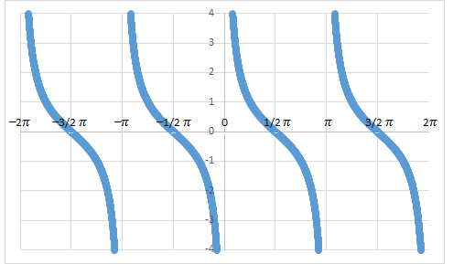

6) Identify the type of trig graph:

a) sin b) cos c) tan

d) cot e) sec f) csc

7) Convert 88º to radians

**Degrees to Radians** multiply degrees by: 

**Radians to Degrees** multiply radians by: 

8) Convert π/15 to degrees

9) Calculate the value of sin π/15 (remember to change your calculator to radians)

|  |  |  |  |  |
| --- | --- | --- | --- | --- |
| **Exact Values of Trig Function** | | | | |
| **Deg** | **Rad** | **sin** | **cos** | **tan** |
| 0 | 0 | 0 | 1 | 0 |
| 30 | π/6 | 1/2 | $\sqrt{3}$/2 | $\sqrt{3}$/3 |
| 45 | π/4 | $\sqrt{2}$/2 | $\sqrt{2}$/2 | 1 |
| 60 | π/3 | $\sqrt{3}$/2 | 1/2 | $$\sqrt{3}$$ |
| 90 | π/2 | 1 | 0 | ∞ |
| 120 | 2π/3 | $\sqrt{3}$/2 | –1/2 | – $\sqrt{3}$ |
| 135 | 3π/4 | $\sqrt{2}$/2 | – $\sqrt{2}$/2 | –1 |
| 150 | 5π/6 | 1/2 | – $\sqrt{3}$/2 | – $\sqrt{3}$/3 |
| 180 | π | 0 | –1 | 0 |
| 210 | 7π/6 | –1/2 | – $\sqrt{3}$/2 | $\sqrt{3}$/3 |
| 225 | 5π/4 | – $\sqrt{2}$/2 | – $\sqrt{2}$/2 | 1 |
| 240 | 4π/3 | – $\sqrt{3}$/2 | –1/2 | $$\sqrt{3}$$ |
| 270 | 3π/2 | –1 | 0 | ∞ |
| 300 | 5π/3 | – $\sqrt{3}$/2 | 1/2 | – $\sqrt{3}$ |
| 315 | 7π/4 | – $\sqrt{2}$/2 | $\sqrt{2}$/2 | –1 |
| 330 | 11π/6 | –1/2 | $\sqrt{3}$/2 | – $\sqrt{3}$/3 |
| 360 | 2π | 0 | 1 | 0 |

10) Calculate the exact value of tan(5𝜋/6)

11) Calculate the exact value of sec (5𝜋/6)

12) What is the amplitude of the graph?

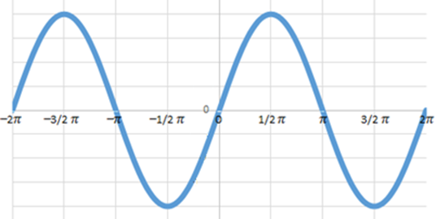

**4**

**- 4**

**- 2**

**2**

a) 1

b) 4

c)𝜋

d) 8

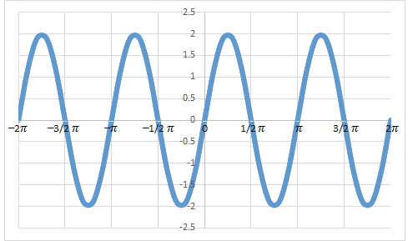13) What is the period of the graph?

a) 1

b) 4

c)𝜋

d) 2

14) The period of a transformed sine function is 3𝜋. What is the frequency?

**Inverse Trig Functions**

15) Calculate the angle in radians: cos−1(/2) =

16) Calculate the angle in radians: cos−1(1/2) =

17) Calculate the angle in degrees: sin−1(-1/2) =

(remember to change your calculator to degrees)

18) Calculate the angle in degrees: tan−1(1) =

19) cos(cos−1() =

20) sin−1(sin(.7854)) =

21) tan(tan−1(−4)) =

**RC Circuit Analysis**

R

XC

50Ω

120Ω

~

VS

22) Calculate the impedance of the RC

circuit with R = 50Ω, XC = 120 Ω:

23) Calculate the phase angle of the RC circuit:

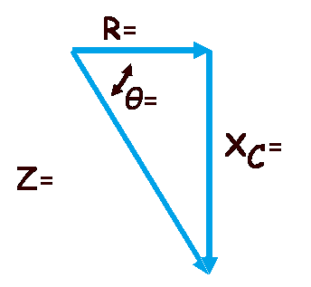24-27) Fill in the impedance triangle values:

**Area of a Triangle**

28) Calculate the area of a triangle with two sides 6 meters and 11 meters with an angle

between them of 112° (don't forget the units!)

29) Calculate the area of a triangle with a = 14m, b = 15m and c = 20m (don't forget the units!)

**Extra Credit – Just for fun!**

Go to the url: <https://www.wolframalpha.com/>

Calculate the area of a triangle: by entering:

triangle 4, 58, 20

in the orange "*Enter what you want to calculate or know about*" block

Click the "=" button

Make a screen print of the result and attach to this document