**Colorado Technical University Instructor:** Dr. Vikki French

**Course:** MATH114 – Analytic Trigonometry VFrench@coloradotech.edu

## Week 3 Readings: Graphs of Trig Finctions and Radian

**Periodic Functions –** repeat a pattern over and over

**Graphs of Trig Functions**

**SINE CURVE TANGENT CURVE SECANT CURVE**

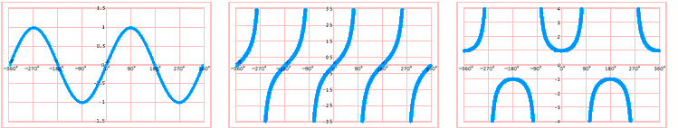

**COSINE CURVE COTANGENT CURVE COSECANT CURVE**

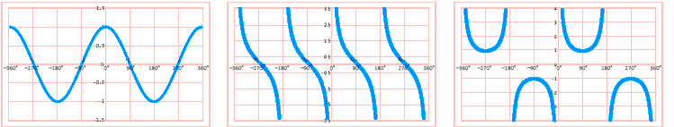

**Recognizing graphs:**

The shape, intercepts, inflexion points and asymptotes are critical

Does it wiggle back and forth? It is a sin or cos

What is it doing at x = 0? If y = 0 at x = 0, it is a sin

If y = something else at x = 0, it is a cos

Does it look like a bunch of stretched-out S’s? It is a tan or cot

What is it doing at x = 0? If y = 0 at x = 0, it is a tan

If x = 0 is an asymptote, it is a cot

Does it look like a bunch of U’s? It is a sec or csc

What is it doing at x = 0? If y is the bottom of a U at x = 0, it is a sec

If x = 0 is an asymptote, it is a csc

**Radians**

You have probably always measured angles in degrees

**Radians** are another way of measuring angles used in CAD and by engineers

It uses the information that the circumference of a circle is 2πr

 Suppose you have a unit circle where r = 1:

**Conversion between degrees and radians:**

To convert from degrees to radians, multiply the degrees by:

$$\frac{π radians}{180°}$$

To convert from radians to degrees, multiply the radians by:

$$\frac{180°}{π radians}$$

Radian measure on your calculator – make sure you change from “Deg” to “Rad” not "Grad"

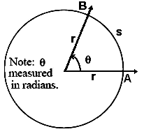

**Arc Length**

To calculate the **radian angle**, *θ* :

*θ* **= ***radian*

where *s* is the length of the circle’s arc

*r* is the circle’s radius

***Note: θ is now measured in radians***

The **length of the circular arc** *s* is: *r θ*

Linear and angular speeds are used to describe motion on a circular path

The linear speed is calculated in terms of the arc length.

The angular speed is calculated in terms of angle *θ*

Linear speed:  where: *t* is time and *s* is the arc length *s* = *r θ*

Angular speed:   where: *θ* is the angle measured in radians and  *t* is time

The relationship between the linear and angular speeds is: *v* = *r* × *ω* where *r* is the

distance from the center of the circle to the point in motion and *ω* is the angular speed

in radians per unit of time

Angular frequency is often referred to as "frequency", but they differ by a factor of 2π



